Ukrainian Red Cross Society

ANNUAL REPORT 2020

Dream! Join! Take action!

CONTENT

Word from the Acting President -
Word from the Director General -
INTRODUCTION -
THE PECULIARITIES OF 2020
СOVID-19 -
Health Care -
Blood Donation -
Hotline -
Assistance to the Vulnerable -
Awareness Campaigns -
Resource Mobilization via SMS -
FUNDS MOBILIZED BY THE SOCIETY IN 2020 -
Analysis of the Earmarked Funds Mobilization -
Mobilization of Non-Earmarked Funds and Funding from Local Budgets -
Humanitarian Aid Mobilization-
Support of Work of the Society’s National Committee and Subordinate Organizations -
ORGANIZATIONAL DEVELOPMENT –
Organizational Development Projects -
VOLUNTEER MANAGEMENT -
Number of Volunteers in Ukraine by Regions -
EMERGENCY PREPAREDNESS AND RESPONSE –
Emergency Response Teams -
Promoting the Role of Volunteers and the Population in Civil Protection (ProVoice) –
First Aid –
TRACING SERVICE –
Coordination of Restoring Family Links (RFL) Activities in Response to COVID-19, Emergencies and Armed Conflict -
HEALTH CARE PROGRAMS AND DIRECTIONS -
Mobile Medical Units –
Visiting Nurses Service -
Medical and Social Support for Tuberculosis Patients -
Donation of Blood and Its Components -
Psychosocial Support -
HUMANITARIAN EDUCATION -
INFORMATION ACTIVITY -
International Humanitarian Law -
Mine Risk -
Cooperation and International Relations -
Memoranda Signed in 2020 –
Fundraising –
Information Management System –
Public Relations –
Risk Communication and Community Engagement -
PROCUREMENT ACTIVITY -

“Pandemic is a special time for goodness and mercy”

MYKOLA POLISHYK
Acting President
Ukrainian Red Cross Society

The year 2020 was a challenge for the Ukrainian society.

COVID-19 has changed all spheres of human life: economy, health care system, culture, social and humanitarian activities. But in addition to the pandemic, there were other emergencies as well: devastating fires in the east of the country, large-scale floods in the west, and exhausting protracted armed conflict in Donbas.

As a part of the world's largest humanitarian movement our organization that has been caring for the lives, health, and well-being of people for over a hundred years, together with our volunteers and staff worked almost 24/7 the whole year in order to assist socially vulnerable populations and support those facing difficult life circumstances due to emergencies.

Even when it seemed that only difficulties laid ahead, we did not give up, but were standing shoulder-to-shoulder with our partners and friends on the way of joint responding to the new challenges. Thus, we were becoming firmer and stronger day after day, gained experience, new knowledge, and adapted to the new conditions. During this difficult period, it became clear that the pandemic was not just sadness, anxiety and fear, but also a special time for goodness and mercy!

The Ukrainian Red Cross’ team, despite everything, has joined the emergency response including the COVID-19 response across the country. We had to resist bravely to the new conditions, sometimes putting ourselves and our loved ones in danger, but were doing it with a sincere heart and deep commitment to the great humanitarian goal of helping people in need.

I am proud of the success of the Ukrainian Red Cross’ team!

"We become stronger working with the partners and the public sector."

MAKSYM DOTSENKO
Director General
National Committee, Ukrainian Red Cross Society

Today the Ukrainian Red Cross Society is the most powerful humanitarian organization in the country, on activities of which the fate of hundreds of thousand people facing difficult life situations depends.

During 2020, we managed to overcome many challenges, particularly to counteract the COVID-19 and assist the socially disadvantaged populations and people affected by the emergencies. Simultaneously, this period was an impetus for development and closer cooperation with the international partners, business sector, and also the start for coordination with various public sector bodies. For example, joint coordination of activities with the National Security and Defense Council of Ukraine, the Commissioner of the President of Ukraine for Volunteering Affairs, Ministry of Health of Ukraine, Ministry of Social Policy of Ukraine, Ministry of Veterans Affairs of Ukraine was started. Moreover, the Ukrainian Red Cross has rejoined the work of the State Commission on Technogenic and Environmental Safety and Emergencies. This allowed us to promptly and smoothly coordinate our activities with the state rescue services and assist victims.

This year, for the first time during the Ukrainian Independence, the court decision was made, which stopped an illegal use of the Red Cross emblem. For a long time, one of the big networks of medical centres in Ukraine used the image of red cross on a white background as its own trademark in its activities, placed it on signs of their medical institutions, websites, used in advertising campaigns and documentation. From now on, the network of medical institutions has stopped the illegal use of the Red Cross emblem. Of course, we will continue this practice.

Recently we have started to develop the strategy for volunteer development together with the international subject-matter experts. The number of volunteers is growing, and we care about their development. We are currently working to ensure that volunteers are supported at the governmental level as well.

This year, thanks to the volunteers, members of the Society, staff and partners, we were able to do an amazing work, which was already noted by the international community.

INTRODUCTION

Ukrainian Red Cross Society is the most powerful humanitarian organization in the country.

Since its first days in 1918, the Society has undertaken a noble mission to take care of the people’s health and well-being, and over 100 years has been promoting the timeless values - mercy, humanity, compassion - and remains a reliable auxiliary to government in the humanitarian field. According to the study by CoreStone and GFK Ukraine, the Ukrainian Red Cross Society is the organization that enjoys the greatest trust and recognition among the domestic non-governmental and charitable organizations. And also, its activity is noted by the expert community of domestic philanthropy: the Society was won the National Competition “Charitable Ukraine”.

Over the centuries of its activity, the Society has followed the remarkable path filled with millions of noble deeds aimed to help the most vulnerable people and victims of emergencies and armed conflicts.

One of the priority activities of the Society’s in Ukraine is addressing the most acute needs of vulnerable populations of the country. The armed conflict in eastern Ukraine and untoward social-economic situation are the causes why many of our citizens need additional support and care. Even though the Society's organizations were left without a significant governmental financial support, by means of which for many years the Society's organizations have arranged their activities in the field of medical and social assistance, employees and volunteers on the ground continue taking care of the beneficiaries.

Today Ukraine is going through the difficult process of democratic transition to social change. We set the goal to make all processes transparent, and to successfully work with the youth. We believe that only if applying joint efforts, our strategic goals become the catalyst for qualitative change.

1918 – I Congress of Ukrainian Red Cross Society (Kyiv, April 18), founding of the Society.

1920 – Organization of free food kitchens for low-income population, food rations distribution.

1930 - Ukrainian Red Cross owns:
• 119 medical facilities
• 206 preventive and children's institutions
• 36 health and recreation centres
• 800 baths
• 300 medical and health centres
• 400 pharmacies and hygiene shops

1941-1945 - During the World War II, over 100 thousand nurses and combat medics were deployed to the front. Ukrainian Red Cross Society also became the initiator of free blood donation. 17 Ukrainian Red Cross nurses were awarded with the Florence Nightingale Medal.

1961 - Establishment of the Visiting Nurses Service.

1986 - Evacuation, resettlement, provision of medical and social, psychological and material assistance to victims of the Chornobyl disaster.

1990 - The Chornobyl Program was launched, and more than $ 35 million USD were raised for humanitarian support of the disaster victims.

1992 - The President of Ukraine issued the Decree “On the Ukrainian Red Cross Society”, which recognized it as the only National Society auxiliary to the public authorities in the humanitarian field.

1993 - Official recognition by the International Committee of the Red Cross in Geneva.
Full member of the International Federation of the Red Cross and Red Crescent Societies.

1999 - Law of Ukraine "On the Symbols of the Red Cross and Red Crescent in Ukraine".

2002 - Law of Ukraine "On the Ukrainian Red Cross Society", which defines:
- legal status
- legal principles
- regularization of relationship involving activities of the Ukrainian Red Cross Society

2009 - The Verkhovna Rada of Ukraine ratified the Third Additional Protocol to the 1949 Geneva Convention on the Red Crystal.

2013-2016 - Establishment of the Emergency Response Teams.


The Red Cross Emblem is a depiction of a red cross on white background. It is used as the symbol of protection during armed conflicts and a distinctive sign of link to the International Movement in peacetime.



The Red Crescent and the Red Crystal are the equivalents of the Red Cross emblem.

All three emblems have the same status under the International Humanitarian Law and the national law of a country, in which they are used. A National Society may use one of the three emblems for indicating its activities.

“The Society has the exclusive right to use the emblems, flags, distinguishing signs and name of the Red Cross stipulated by the Decree of the President of Ukraine of October 28, 1992 “On the Ukrainian Red Cross Society”, the Law of Ukraine “On Symbols of the Red Cross, the Red Crescent, and the Red Crystal in Ukraine” of June 8, 1999, the Rules of the Red Cross and Red Crescent emblems use by the National Societies of 1991, adopted by the XX International Conference (Vienna, 1965) and revised by the Council of Delegates (Budapest, 1991).

Additional Protocol III of December 8, 2005 (Geneva, 2005), paragraph 2 of Resolution 1 of the XXIX International Red Cross and Red Crescent Conference of June 22, 2006, and the URCS Statute for the purposes defined by the International Red Cross and Red Crescent Conferences in accordance with the Geneva Conventions of 1949…”

(Excerpt from the Statute of Ukrainian Red Cross Society)

THE PECULARITIES OF 2020

COVID-19
2020 was a challenge for everyone, since the COVID-19 pandemic covered the whole world and affected almost all spheres of life. People panicked. Educational institutions and stores were closed for quarantine, and medical facilities lacked rooms for hospitalization of patients and vital equipment. Schools and stores were closed, and hospitals lacked beds and necessary equipment. The information space was immediately filled with data about the spread of coronavirus infection and prevention methods, but, unfortunately, not always they were the correct ones. All this could lead to irreversible negative effects for both the lives of people and the country in general.

Ukrainian Red Cross Society, as the largest humanitarian organization in the country, together with the partners immediately has joined the national fight against the pandemic and assisted those who needed it the most. Assistance was provided not only to vulnerable populations, but also common people in difficult life circumstances and, of course, medical staff, who, even in the absence of personal protective equipment, was fighting each day for every patient's life.

To render prompt and quality assistance, the Society has established close cooperation with international partners, business sector and started active interactions with various public sector bodies. In particular, there was initiated the joint coordination of activities with the National Security and Defence Council of Ukraine and the Commissioner of the President of Ukraine for Volunteering Affairs. Moreover, the Ukrainian Red Cross has rejoined the work of the State Commission on Technogenic and Environmental Safety and Emergencies for emergency coordination of actions and communication, including activities for fighting the coronavirus infection.

Health Care

Medical workers are at the forefront of fighting the pandemic, every day saving the lives of millions of people and risking their own lives. In addition to being exhausted emotionally and physically by overtime work and constant stress, they faced new challenges: lack of personal protective equipment, necessary facilities, and insufficient bed capacity.

Ukrainian Red Cross Society, together with the partners, have contributed to the response to this challenge. Medical equipment was distributed to base hospitals: lungs ventilators (LV), analysers of blood gas, electrolytes, metabolites and haemoglobin, patient monitors and defibrillators.

Ukrainian Red Cross Society regularly provides medical facilities with the personal protective equipment: protective suits, medical masks, respirators, gloves, and antiseptics. Moreover, during the year, the specially trained volunteers of the Society delivered the COVID-19 prevention and protection trainings in almost 200 hospitals in all regions of Ukraine.

Blood Donation

During the pandemic, the number of blood donors decreased sharply, and therefore, the country's hospitals were catastrophically short of donor blood. Therefore, the Ukrainian Red Cross Society organized the all-Ukrainian blood donation and safe blood donation awareness campaign during the epidemic in order to support people with severe diseases, such as cancer and blood disorders. Futher the cooperation on blood donation promotion was launched with actors and athletes, as well as the Armed Forces of Ukraine to engage the military staff in blood donation.

To the World Blood Donor Day, the Ukrainian Red Cross Society together with the Ministry of Youth and Sports of Ukraine have initiated the all-Ukrainian long-term blood donation campaign "Victory is in Our Blood". As a result, in the first few weeks almost 8,000 blood donors from all regions of Ukraine have participated in the campaign. This number is 2.5 times bigger than in 2019.

Hotline

During the first wave of СOVID-19, the Ukrainian Red Cross Society has launched the information centre, which provided answers to questions about the Society's work, including those related to the fighting against coronavirus. The centre also collects proposals on volunteering and cooperation, and processes information about the needs of people in difficult circumstances.

The Society’s volunteers, who are specially trained in first psychological aid and basics of nonviolent communication, provide services in the centre.

Moreover, the Ukrainian Red Cross Society assisted the Ministry of Health of Ukraine in maintaining the hotline established for reduction of discrimination, stress and panic, and the population awareness raising.

Assistance to the Vulnerable

Food products, hygiene items, medicines and personal protective equipment kits were provided to lonely and living alone older people, disabled persons, multi-children and low-income families, the Romani, homeless people and other vulnerable populations throughout Ukraine thanks to efforts of regional and local organizations of the Ukrainian Red Cross Society and support of local authorities. Moreover, by efforts of the Emergency Response Teams there was organized the delivery of meals and food products to vulnerable people staying under quarantine in all regions of Ukraine.

Simultaneously, the Ukrainian Red Cross Society’s Tracing Service supported older people remaining in self-isolation, geriatric homes, and hospitals. The Tracing Service staff also assisted in restoring and maintaining family links, including support to foreigners who have to stay in Ukraine temporarily due to quarantine and border closure.

Support was rendered to homeless people as well – they were regularly provided with hot meals in different parts of the country.

Awareness Campaigns

Volunteers of the Society systematically carry out the COVID-19 awareness activities in different parts of the country. The organizations of Ukrainian Red Cross Societies never tire to explain everyone how the coronavirus spreads, importance of the regular proper hand hygiene, risk mitigation of the COVID-19 infection, and how to support and care for people at high risk of severe coronavirus infection and complications if they get infected during the pandemic.

For this purpose, more than a million copies of printed materials of various formats were developed, published and distributed throughout the country. They could be seen in almost all shops, schools, public transport, and government agencies.

In order to reach as many people as possible with the reliable information about COVID-19, almost fifty videos were created, 18 of which were recognized a social advertising and were broadcasted by national channels of the country. By the way, recently the Ukrainian Red Cross Society has received three awards in the thematic nomination "STOP! COVID" at the 12th National Festival of Social Advertising.

This year, the Society in cooperation with Ukrainian national celebrities have launched the audiobook "My Hero Is You" by the British author and illustrator Helen Patuk. The audiobook correctly explains children everything that happens during the pandemic, and shows how they can fight COVID -19.

The book has been already translated into many languages, dialects, and Braille, and adapted in various ways in many countries to reach the largest possible audience of children and parents worldwide.

Ukraine also took part in the topical project and created the audiobook "My Hero Is You," voiced by famous Ukrainian artists, particularly Oleh Skrypka and Svetlana Tarabarova.

Resource Mobilization via SMS

One of the important events of the year implemented by the Ukrainian Red Cross Society together with Vodafone Ukraine was the launch of the short number 88033 to collect charitable contributions for responding to the COVID-19 pandemic. From now on, every Vodafone Ukraine mobile subscriber can contribute to supporting medical facilities and vulnerable populations in fighting the effects of the pandemic. To do this, a person should send an SMS-message, charged 20 UAH, to the short number 88033. The service is available in the prepaid tariffs only.

"We believe that more can be achieved through joint efforts, so we launch own social projects and eager to join important initiatives of our partners. We support the Ukrainian Red Cross in its significant work done to overcome the COVID-19, and we are grateful to our subscribers, who will support the Red Cross project via the SMS donations."

Victoria Ruban
Head of Public Relations
Vodafone Ukraine

Funds Mobilized by the Society in 2020

In 2020, the Ukrainian Red Cross Society has mobilized 323,327.70 thousand UAH for statutory activities and support for people who needed it the most:

Subordinate organizations of the Society with support of the National Committee have attracted and utilized 241,387 thousand UAH.

Since the beginning of the year the Society’s organizations have received:
- non-earmarked funds for statutory activities - 5.4% of the total income
- inventory resources donated as in-kind and humanitarian charitable aid – 45.5% of the total income
- funds for implementation of international projects, programs and charitable activities supported locally – 49.1% of the total income.

Structure of incomings to the URCS subordinate organizations in 2020, thousands UAH:

- Non-earmarked funds – 13,019
- Contributions of inventory for statutory activities of the Society’s organization – 109,737
- Earmarked funds (budget, projects, etc.) – 118,631

Analysis of the Earmarked Funds Mobilization

In 2020 the regional organizations have attracted the earmarked funds in the amount of 118,631 thousand UAH (for implementation of international projects, programs and charitable activities supported locally).

Earmarked funds - contributions for the statutory activities and ensuring the statutory activity of the Society’s organizations in 2020, thousand UAH

Funds recognized as humanitarian assistance – 5,323
Budget funds (local) – 7,603
Funds received by URCS for projects implementation – 30,367
Earmarked funds raised independently (incl. local projects) – 75,339

The largest amounts of funding for implementation of charitable projects and programs:

- Donetsk Regional Organization of Ukrainian Red Cross Society received 17,070 thousand UAH from the National Committee of Ukrainian Red Cross Society
- independently raised funds (incl. local projects) by Donetsk Regional Organization of Ukrainian Red Cross Society in the amount of 43,873 thousand UAH and Odesa Regional Organization of Ukrainian Red Cross Society in the amount of 10,216 thousand UAH
- Kyiv City Organization of Ukrainian Red Cross Society attracted the biggest amount of funds from the local regional budget – 2,242 thousand UAH

Incomings from local budgets in 2020, thousand UAH

Mobilization of Non-Earmarked Funds and Funding from Local Budgets

Filling of budget of the Ukrainian Red Cross Society’s organizations depends on the ability to attract the non-earmarked financial support and successful cooperation of the organization’s leadership with local authorities for funds mobilization in order to ensure the statutory activity. Thus, high indicators of mobilization of the non-earmarked charitable contributions and donations from local budgets in 2020 were achieved by the following organizations of the Society: Volyn, Zaporizhizhia, Ternopil, Zakarpattia, Mykolaiv, Vinnytsia and Dnipropetrovsk Regional Organizations of Ukrainian Red Cross Society.

Mobilization of non-earmarked charitable contributions, donations, and other non-earmarked charitable funds by the regional organizations of the Society in 2020, thousand UAH

Analysis of in-kind income of the Society

clothes and shoes – 23.1%

food – 8.8%

“other goods” – 6.0%
bedclothes, blankets, furniture, household appliances

medical supplies and medicines – 6.3%

detergents and hygiene products – 3.8%

The National Committee of Ukrainian Red Cross Society has transferred in-kind assistance to the regional organizations – 52.0% (clothes, blankets, bedclothes, banners, furniture, appliances, medical equipment, office equipment, certificates, printed materials, stationery, and clothes with the Ukrainian Red Cross Society’s logos, goods for psychosocial support, etc.).

In 2020 the organizations have mobilized in-kind income with own efforts to the amount of 39,269.6 thousand UAH.

The largest in-kind income was attracted by the organizations:

- Kyiv City (6,760.3 thousand UAH)
- Donetsk (4,513.3 thousand UAH)
- Dnipropetrovsk (3,609.8 thousand UAH)
- Zhytomyr (3,314.9 thousand UAH)
- Kharkiv (2,893.2 thousand UAH)
- Zakarpattia (2,555.2 thousand UAH)
Humanitarian Aid Mobilization

In 2020, the Society’s organizations have mobilized humanitarian aid to the amount of 18,407.2 thousand UAH from the Polish Red Cross, German Red Cross, the Netherlands Red Cross, and the Swedish Red Cross, etc.

7 regional organizations of the Society have independently mobilized humanitarian aid:

- Zakarpattia (13,294.4 thousand UAH)
- Ternopil (1,820.1 thousand UAH)
- Odesa (1,526.6 thousand UAH)
- Luhansk (950.1 thousand UAH)
- Volyn (513.5 thousand UAH)
- Mykolayiv (83.2 thousand UAH)
- Vinnytsia (82.7 thousand UAH)

Support of Work of the Society’s National Committee and Subordinate Organizations

In 2020, the National Committee of the Society has raised income for the Society’s charitable activities to the amount of 167.629 million UAH and coordinated international charitable projects/programs in the subordinate organizations of the Society in order to support:
• internally displaced persons, low-income, many-children families, living alone, elderly citizens of Ukraine, and psychosocial support programs, medical and social programs for fighting AIDS, tuberculosis, as well as the Visiting Nurses Service, health units, people affected by fires and floods, and the COVID-19 response;
• programs for the youth movement support, strengthening of the Society’s Emergency Response Teams, reconstruction of damaged/destroyed housing in eastern Ukraine, for support of social and medical facilities, including 30,367 thousand UAH raised for financial support of the Society’s regional organizations from the National Committee of Ukrainian Red Cross Society, International Federation of Red Cross and Red Crescent Societies, International Committee of the Red Cross, international organizations, the State Budget of Ukraine, fundraising campaigns for implementation of humanitarian charitable programs and events.

UNDS MOBILIZED BY THE SOCIETY

URCS NC in partnership with the international donors has mobilized 167,629 thousand UAH for charitable projects implementation.
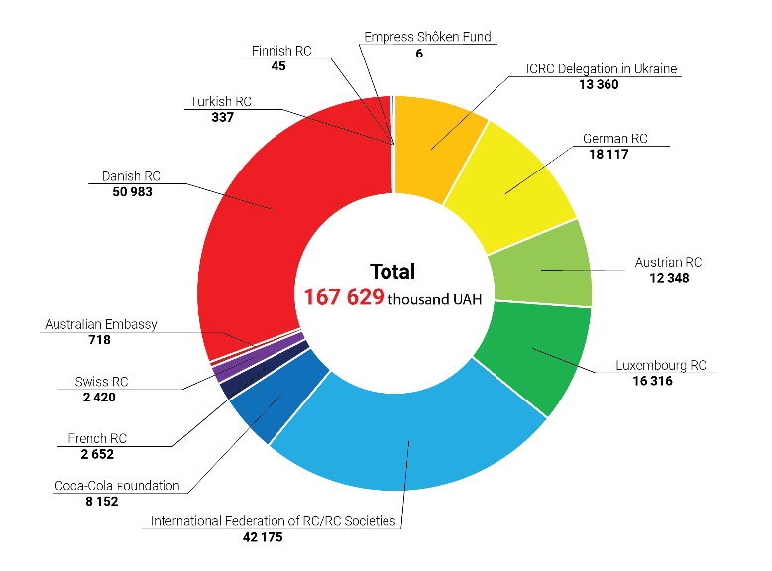
COVID-19 Response
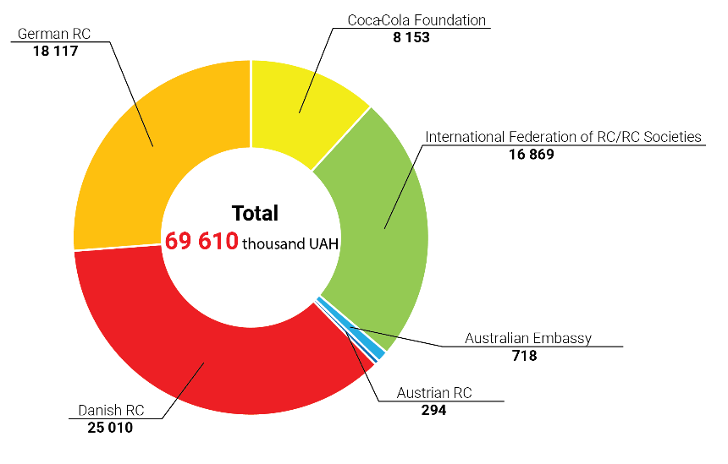

Danish Red Cross
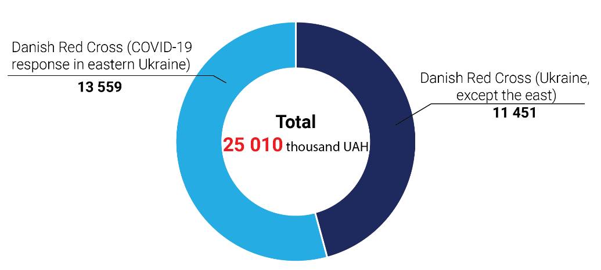

ORGANIZATIONAL DEVELOPMENT

Organizational Development Projects

In 2020, the BraVo program supported by the Danish Red Cross was implemented in 12 local organizations: Kyiv city - Podil District Organization; Kherson region - Genichesk, Kalanchak, Korabelna, Bilozersk District Organizations and Kherson City Organization; Dnipropetrovsk region - Kryvyi Rih City District Organization; Kharkiv region - Kupiansk City District and Krasnograd City Organizations; Zaporizhzhia region - Berdiansk City Organization; Vinnytsia region - Vinnytsia City Organization; Lviv region - Shevchenkivsk District Organization; Mykolaiv region – Yuzhnoukrainsk City Organization.

With support of the International Committee of the Red Cross the BraVo program was implemented in 9 local organizations: Donetsk region - Mariupol City Organization, Volnovakha District Organization, Bakhmut City Organization, and Myrnohrad City Organization; Luhansk region - Lysychansk City Organization and Severodonetsk City Organization; Kyiv region - Bila Tserkva City Organization; Kyiv city - Dniprovsk District Organization; partly Zakarpattia region - Uzhhorod City Organization.

In 2020, the standard national approach to organizational development of local organizations was put in place, and included the following tools:

• ВОСА, as a key institutional methodology for branch development and the organizational development entry point for local organizations. ВОСА was conducted in 9 new organizations.

- ВОСА-review - an event for assessment of implementation of the plans, which were drafted during ВОСА, and designing of a new 12-month activity and development plan. 11 ВОСА-reviews were conducted in the pilot organizations, which joined in 2018-2019.
- Interregional Advisers System for support of the organizations in implementation of their annual BOCA plans and key directions of activity – 2 interregional experts have been working since November 2020.
- System of regular reporting - infographics of local organizations' activities (individual for each one) created twice a year to enhance transparency and accountability to the community.
- Introduction of the Ukrainian Red Cross Society’s Branch Handbook as a guidebook for local organizations on activity implementation and main processes in all aspects of work. A series of webinars were conducted to explore selected sections of the Handbook.
- Introduction of experience exchange system among the pilot organizations thanks to: joint online meetings (6 times a year), re-publications in the joint Facebook group and Viber chat, meetings of 5 organizations in Podolsk Organization in Kyiv.
- Creation of mobile training teams (MTT) to transfer knowledge and best practices by the team of experts (trainers) at the district and regional levels. During 2020, 3 two-three-day trainings were conducted for 66 representatives of the operating local and regional organizations in Zaporizhzhia, Lviv, and Mykolaiv regions, covering the relevant topics requested by the participants.
- Implementation of team building activities on the ground - one-day meetings/field trips for local organizations’ teams consisting of head, governing board members, active volunteers, and partners with the purpose of plan implementation evaluation and joint recreation. The activities took place in 16 pilot organizations in August-October 2020 after the COVID-19 active response phase, that allowed the team members to receive support and recognition from the organizations.
- Call for Projects - to practice project application writing skills and funds mobilization by the winners. In 2020, 4 local organizations received funds for implementation of 4 grants on development of the Red Cross resource generating services. The total funding of the local organizations’ grants in 2020 amounted to 487,823 UAH:
  - Bila Tserkva City Organization, project "The Red Cross Aroma Room"
  - Podolsk District Organization, project "The Red Cross Charity Town" (Charitable Town of the Red Cross);
  - Bakhmut City District Organization, project "Eco-Workshop";
  - Yuzhnoukrainsk City Organization, project Active Longevity Club "Velvet Season” for elderly and disabled people.

• Support was provided in improving the material and technical base to increase the quality of services provided to the population and working conditions of employees and volunteers: toilet rooms in 3 organizations were repaired; safe space for holding events was created in Yuzhnoukrainsk City Organization; 21 organizations were provided with hygiene kits to support the appropriate indoor sanitation, branded items to acknowledge efforts of volunteers and partners, and 65 boxes for fundraising campaigns; computer and office equipment for workplace arrangement were provided to 5 pilot organizations; information stands and printed materials for activities promotion among the population were provided to 12 organizations.
• There also were conducted training at the request: trainings on social services procurement for 29 organizations, and project writing trainings for 28 organizations in December.

• OD-Forum, the annual event for employees (mostly heads of organizations) and volunteers of local organizations. During the forum 38 participants from 20 organizations exchanged experience on local development, volunteer management, cooperation with communities and running the Active Longevity Clubs. Together they worked through the mechanism for local population's needs assessment for provision of the relevant social services, and mastered the project writing skills.

All pilot organizations participated and continue actively participating in the COVID-19 response, receiving the centralized support from the National Committee of Ukrainian Red Cross Society and mobilizing the local resources:
• distribution of awareness materials provided by the National Committee of Ukrainian Red Cross Society, and conducting of awareness lectures for different audiences
• 8 of 12 pilots organizations arranged fabrication of sewed masks by volunteers, using materials received from local partners, the other 4 organizations used ready-made masks from local partners;
• Lysychansk City Organization has created the Assistance Center on the basis of the Volunteer Center. Here volunteers sewed protective masks, and members of the Emergency Response Teams packed and delivered food products to the categories of population, who could not leave home. Thus, 1,964 vegetable boxes were distributed thanks to cooperation with the local vegetable warehouses.
• Berdiansk City Organization independently wrote a grant proposal and gained support under the United Nations Program for Reconstruction and Peacebuilding for the project on first aid training of teachers and vulnerable populations.
• Podil District Organization repeatedly received financial support from the local district authorities, and together with Solomianka and Pechersk District Organizations of Kyiv City Organization have won the TOP-100 Best Non-Governmental Organization Projects Fair organized by the Public Communications Department of Kyiv City State Administration.
• Krasnohrad City Organization continued receiving financial support from local authorities for home based medical and social care. At the same time, Kalanchak Organization actively recruited leaders of newly created united territorial communities of the district to the ranks of the Society’s members.
• Yuzhnoukrainsk City Organization conducted renovation works in the office.
• Kryvyi Rih City Organization, in comparison to the previous year, has enhanced cooperation with non-governmental organizations and educational institutions, that allowed to renew the volunteer staff in such areas as Emergency Response Teams, blood donation promotion, first aid training, and population psychosocial support activities.
• The number of members has doubled in 11 pilot organizations.
• Organizations have updated the governing board composition. The number of members was brought in balance with the scale of the organizations' existing activities (the number reduced), and the participation rate was increased (active volunteers and partners included). All pilot organizations held joint planning and team building activities among the governing board members and active volunteers.
• Severodonetsk and Lysychansk City Organizations actively responded to fires in Luhansk region: carried out the victims needs assessment, collected aid from the population and partners, and coordinated actions with the local authorities. Simultaneously, several pilot organizations collected aid at the local level and handed it over to the population affected by the fires.

VOLUNTEER MANAGEMENT

Since 2014 and until now Ukraine has been facing the crisis due to the armed conflict in the East. Every year the number of volunteers grows, their skills and acquired knowledge increase, and all efforts are directed to responding to the country's humanitarian challenges. Volunteers are involved in the Ukrainian Red Cross Society’s activities in such areas as medical and social support, first aid population training, psychosocial support and work with children, Emergency Response Teams, promotion of international humanitarian law, etc.

For the Ukrainian Red Cross Society, as well as for Ukraine and the world, the year 2020 was marked by the sudden onset of the COVID-19 pandemic. Undoubtedly, the new epidemiological and quarantine conditions have become a challenge in the daily activities of volunteers too. Special attention was paid to the safety of volunteers. In particular, for this purpose the Society has developed and disseminated special safety instructions for volunteers, their coordinators, and leaders; numerous personal protective equipment was purchased and distributed to the volunteers - masks, respirators, goggles, protective suits; online sessions for psychosocial support and phone consultations by professional psychologists were arranged for volunteers involved in the pandemic response, as well as offline sessions on safety rules for the Emergency Response Team members.

As of December 2020, the Society’s volunteer database had 3,295 officially registered volunteers, who provide support in the following regions: Volyn, Zakarpattia, Ivano-Frankivsk, Lviv, Ternopil, Dnipropetrovsk, Zaporizhzhia, Mykolaiv, Odesa, Kherson, Donetsk, Luhansk, Poltava, Sumy, Kharkiv, Kyiv, Kirovohrad, Cherkasy, Chernihiv, Vinnytsia, Zhytomyr, Rivne, Chernivtsi, and Kyiv city.

Number of Volunteers in Ukraine by Regions

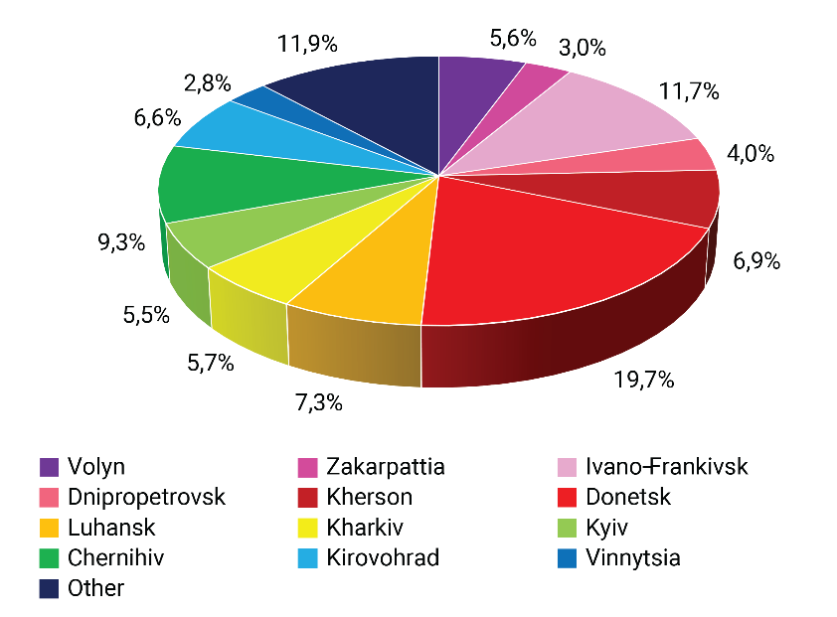

In 2020, the Volunteer Development Unit has implemented the following key activities and made achievements:

- X National Volunteer Assembly, where representatives of all regional organizations of the Society (65 volunteers) had an opportunity to share valuable experiences, listened to important information sessions on the safer access concept, international humanitarian law, psychosocial support, first aid, and elected new member composition of the Volunteer Development and Youth Policy Commissions of Ukrainian Red Cross Society. For the first time in the Society’s history this event was held online. The Assembly also celebrated the International Volunteer Day. On December 5, 449 best volunteers from all regions were awarded with prizes.
- For the first time in the Society’s history, the regional volunteer assemblies were held in all 5 regional clusters of the Society (Western (Lviv city), Central-Western (Zhytomyr city), Central (Kyiv city), Eastern (Sviatohorsk city), and Southern (Kherson city). In spite of the pandemic, we managed to conduct these events offline in compliance with all quarantine requirements. In total, 94 volunteers participated in the regional assemblies.
- Supported by the Danish Red Cross and the Danish Red Cross Youth, the Youth Involvement Strategy 2021-2025 is being finalized, and the creation of the Volunteer Development Strategy 2021-2025 has started. These documents, availability of which is envisaged by the standards of the International Federation of Red Cross and Red Crescent Societies, are being developed for the first time in the history of the Ukrainian Red Cross Society.
- Drafts were developed for: Regulations on Regional Volunteer Leaders Election to streamline the election procedure, Code of Conduct for volunteers, employees, and members of the Society, as well as the volunteer activity profile system; the algorithm for exclusion of the organization’s members was developed. Adoption of these documents is expected in the first half of 2021.
- The original training session on history, theory and practice of the Fundamental Principles of the International Movement was improved, and in the future, it will become an integral part of training of the Society's active volunteer leaders.
- The Volunteer Development Unit and the Volunteer Development and Youth Policy Commissions of Ukrainian Red Cross Society also participated in advocacy activities of the Society. Namely, in August 2020, the proposals to draft law on amendments to the acting Law of Ukraine on Volunteering and the Concept of the National Volunteer Alliance, an advisory body to the Office of the President of Ukraine, were developed and submitted to the Commissioner of the President of Ukraine for Volunteering Affairs.
- During the year, 24 new trainers on volunteer management were prepared. For this purpose, the special Volunteer Management Trainer’s Handbook was developed for the first time.
- For the first time, 10 regional organizations of the Society managed to maintain a volunteers database on the Salesforce platform, which is already used by the National Societies of Belarus, Canada, Switzerland, etc. For this purpose, a series of training webinars was held for the selected focal persons, who were responsible for the database maintenance in the regions. In the future, it is planned to implement a gradual transfer of the entire national volunteer database to the above platform.
- For the first time, the online training for trainers on the updated volunteer induction course (13 participants) was piloted. Regular induction courses for new volunteers were put in place at the regional and district organizations.
- In 2020, the Unit’s staff also performed other important educational work: translated "The Fundamental Principles of the Red Cross. Commentary" by Jean Pictet into Ukrainian (electronic version), and printed the translated biographies of the founders of the International Red Cross and Red Crescent Movement Henri Dunant and Gustave Moynier written by Roger Durand and François Bugnion respectively (500 copies each). In 2021, an official presentation of the Ukrainian edition is planned with the participation of representatives of the Henri Dunant Society (Geneva, Swiss Confederation). With the active support of the Unit, the online training courses of the Learning platform of the International Federation of Red Cross and Red Crescent Societies on proper hygiene and corruption prevention among volunteers, staff, and leadership of National Societies also were translated into Russian.
- The insurance mechanism for the Society's volunteers and employees during the COVID-19 pandemic was developed with assistance of the Unit's staff and support of the International Federation of Red Cross and Red Crescent Societies and Lacoste Corporation.
- The Unit’s staff actively participated in development and implementation of the unique pilot training program for youth leaders of the Society "Youth Leader Path" in Dnipropetrovsk and Kharkiv regions (October 5-10, Kyiv, 18 participants) within the project "Youth Leaders of Ukraine". In the future, it is planned to increase this program's capacity in order to reach all volunteer and youth leaders of the Society.
- In March-May 2020, the Unit coordinated work of more than 20 volunteers, who carried out daily maintenance of the information call centre of the Ministry of Health during the first wave of the COVID-19 pandemic.
- In 2020, 7 schools of social initiatives were conducted for almost 100 volunteers. Participants learned the basics of project management and writing of own social mini-projects.

Altogether, 2020 drew a specific line under the transition period in the Society’s development in general and the volunteer movement development in particular, that began in 2014. During this period, the creation of a qualitatively new volunteer management system made up the foundation for the future planned strategic development of volunteer management. In 2021, upon adoption of a new Statute and Development Strategy of the Society, the implementation of large-scale youth engagement and volunteer movement development program 2021-2025 should begin on a planned basis.

EMERGENCY PREPAREDNESS AND RESPONSE

Ukrainian Red Cross Society ensures delivery and distribution of necessary humanitarian and charitable assistance to the population in case of emergency. Assistance is provided upon a proper assessment of needs and available resources. The Society also runs the Emergency Relief Fund: reserves emergency stock; develops and implements financial support programs for victims.

The Society is a part of the national emergency response system. The President of the Society is a member of the State Commission on Technogenic and Environmental Safety and Emergencies.

The Society coordinates its work with the public authorities, local governments and other organizations involved in the emergency response. The Society has specially equipped Emergency Response Teams; they consist of staff and volunteers of the Ukrainian Red Cross Society, who regularly undergo the relevant special training.

Emergency Response Teams

In 2020, activities of the Emergency Response Teams (ERT), apart from the emergency response and relief to population and various social mass events, included responding to challenges, which the Society faced due to the COVID-19 pandemic.

As of the end of 2020, the system of the URCS Emergency Response Teams formally consisted of 21 teams and 13 groups in 20 regions of Ukraine. Emergency Response Teams brought together 440 active volunteers of the Society.

The main activities with increased health risk, which were carried out during the year, were the delivery of charitable assistance to vulnerable populations in difficult situation due to the pandemic, trainings on personal protective equipment (PPE) use for medical staff, accompaniment of trains carrying the evacuated citizens of Ukraine, sports, cultural and socio-political events, emergency response, and trainings, and made 953 events in total. Assistance was provided to 899 injured persons; the most common injuries were bruises, bleeding, wounds, traumatic brain injuries, poisoning (tear gas, alcohol, etc.), and sprains of varying severity. There were distributed about 10 thousand hot meals, food parcels and medical kits to people facing difficult live situation due to the pandemic. ERT volunteers conducted training on PPE use for 6,537 medical workers in 165 hospitals. The total number of hours worked was 5,661, which if calculated in man-hours on average concluded more than 22,000 volunteer-hours per year. Vehicles of different types were used more than 600 times during shifts (including private vehicles of volunteers), that significantly improved the ERT’s mobility and the speed of assisting the victims.

ERT members took part in many exercises, in that number international ones, including the Rapid Trident 2020.

During the year, ERTs accompanied 6 trains with Ukrainian citizens, who were evacuated from Poland, deployed about 30 temperature screening points throughout Ukraine, participated in the implementation of quarantine and epidemiological measures, and conducted training on PPE use in 165 base hospitals for 6,537 medical workers. In 2020, ERT volunteers responded to large-scale emergencies: gas explosion in residential building in Kyiv; fires in Kyiv and Zhytomyr regions; floods in the west of Ukraine; and fires in Luhansk region.

Training on search of victims in forest started for the National Committee's ERT.

The pandemic had impact on the number of mass events, but it only encouraged the Emergency Response Team volunteers to improve their emergency response capacity under threat of the epidemic, that’s why the Annual ERT Meeting was held in a new format. For the first time there was conducted an ERT competition in accordance with the ERT operating protocols during the Meeting. The Meeting was devoted to emergency response within the framework of epidemic restrictions.

The COVID-19 Response:

- 385 response measures implemented during the year
- over 470,000 personal protective equipment for medical staff distributed
- over 50,000 hygiene kits distributed to vulnerable populations
- over 65,000 people received food kits (since March 2020)
- trainings on COVID-19 prevention and safety were conducted in almost 200 hospitals in all regions of Ukraine. Moreover, sessions on personal protective equipment use for medical facilities and enterprises continued.
- medical equipment including lung ventilators and defibrillators provided to hospitals

For example, in October 2020, 10 Covid hospitals in 5 regions received 1,000 respirators and 60 kits of protective suits and goggles. More than 13,489 beneficiaries received assistance, including:
- hygienic / food / psychosocial kits / blankets and bedding
- psychosocial support services
- participated in personal safety sessions/ workshops.

Flood Relief

In June 2020, the largest flood in the last decade occurred in west of Ukraine. Thousands of houses and households were damaged, hundreds kilometres of roads, dams and bridges were partially destroyed, and transport connection between dozens of settlements was disrupted.

Ukrainian Red Cross Society’s volunteers and employees not only supported the victims resettlement, but also distributed hygiene and food kits for more than 10,000 victims.
The first stage of response was aimed at maintaining the sanitary and epidemiological safety in the affected areas. In July, 3,750 essentials hygiene kits were distributed to population of Ivano-Frankivsk (3,040 kits), Zakarpattia (210 kits), and Chernivtsi regions (500 kits).

During the second stage of response the Society’s volunteers and employees distributed over 1,400 food kits to population of Chernivtsi (1,314 kits) and Ivano-Frankivsk regions (86 kits). One kit weighted about 20 kg and consisted of long-term storage products: grains, pasta, oil, canned food, sugar, flour, and condensed milk. Also, in addition to food kits, 1,026 hygienic kits were distributed in Ivano-Frankivsk region.

Assistance was provided within the framework of cooperation between the Ukrainian Government and the Ukrainian Red Cross Society in coordination and with support of the International Federation of Red Cross and Red Crescent Societies, Danish Red Cross, the United States Agency for International Development (USAID), and the British Embassy in Ukraine.

"I am grateful to the Ukrainian Red Cross Society, which made every effort to promptly help those affected by floods in the western regions. By combining efforts of the Government and international organizations we have managed to reduce the negative consequences of the natural disaster and provide victims with the most needed things."

Olga Stefanishyna,
Vice Prime Minister of Ukraine for European and Euro-Atlantic Integration

Fire in Luhansk Region

The Ukrainian Red Cross Society's employees and volunteers have been working around the clock since the emergency onset and assisted more than 200 victims, who were evacuated by rescuers during the fire in Luhansk region.

In particular:

- provided first aid and psychological first aid to victims
- helped to transport, register, and accommodate the victims
- distributed food and hygiene kits, bed clothes and blankets
- collected and sorted the necessary clothing, food products, and drinking water for the victims
- distributed personal protective equipment, sanitizers and gloves to rescuers, volunteers, and victims for the COVID-19 prevention
- placed posters of the Tracing Service of Ukrainian Red Cross Society in the evacuation locations so that make people aware what to do in case of family links loss
- Emergency Response Team of Luhansk Regional Organization of Ukrainian Red Cross Society transported 15 persons with reduced mobility to points of assistance and temporary residence.

It will be recalled that on September 30 and October 1, 8 large-scale forest fires broke out along the demarcation line. The most severe situation was recorded between Stanytsia-Luhanska and Severodonetsk, where the fires became threatening and swallowed up 32 settlements. As a result of the fires, 9 people died and 17 people were hospitalized. 150 people were evacuated. According to preliminary estimates, the fire travelled more than 13 thousand hectares.

Promoting the Role of Volunteers and the Population in Civil Protection (ProVoice)

The ProVoice project is aimed at strengthening the capacity of organizations working in the field of civil protection in Ukraine, Belarus and Moldova through development of three main areas: volunteer management, spontaneous volunteering, and public awareness on disaster response.

Cooperation within the project

- International level: Austrian Red Cross, Danish Red Cross, Bulgarian Red Cross, Belarus Red Cross, NGO EcoContact (Moldova) – sharing experiences, organization of joint events and support of development of regulatory documents and video/ printed materials for work with volunteers and population.
- National level: the State Emergency Service of Ukraine (SES of Ukraine), Civil-Military Cooperation of the Armed Forces of Ukraine – participation in activities and coordination of actions.

Project achievements in January - March 2020:

To promote the importance and raise the population awareness about the emergency preparedness, the video "How to Be Prepared for an Emergency?" was created and published on all official channels of the Ukrainian Red Cross Society. The video explains how to pack an emergency bag, make a family evacuation plan for an emergency, and emphasizes the importance of first aid training.

In order to strengthen coordination between all civil defence actors in the field of development of spontaneous volunteering, volunteer management, and public awareness on emergency preparedness and response, the recommendations and key messages were developed and printed in a leaflet format in the amount of 100 pieces.

Based on the results of workshop on spontaneous volunteering development in Ukraine held with participation of experts of the Austrian Red Cross and representatives of the SES of Ukraine, Civil-Military Cooperation and relevant units of the Ukrainian Red Cross Society, the recommendations on spontaneous volunteers coordination were developed and then tested during a one-day simulation exercise of the Emergency Response Team of Sumy Regional Organization of Ukrainian Red Cross Society. Representatives of the State Emergency Service of Ukraine and the National Police of Ukraine were also invited to participate in the simulation.

To strengthen the emergency response capacity of the Society, 3 tents were purchased and handed over to the Emergency Response Teams of Sumy, Rivne, and Dnipropetrovsk Regional Organizations.

Under the project within the Society’s COVID-19 prevention awareness campaign, 50,000 pocket calendars (with personal safety tips in context of acute respiratory disease outbreak) were published to raise public awareness on prevention measures, and the cartoon for children "Superheroes in Quarantine" was created aiming to inform children about the importance of adhering to all prevention and safety measures, arranging personal schedule and supporting loved ones during self-isolation.

First Aid

Under condition of socio-economic instability, the first aid population training is an important component of human security. The Society's training programs are certified by the specialized Global First Aid Reference Centre of the International Federation of Red Cross and Red Crescent Societies, that’s why the certificates issued upon completing the training are currently recognized in 192 countries.

In 2020, 2,675 persons attended 6-hour first aid trainings; and 1,135 persons attended 12-hour first aid training. 16,742 persons took part in first aid workshops and master classes.

The second Summer School for first aid instructors was organized and held. Instructors from Donetsk, Luhansk, Chernihiv, Ternopil, Kharkiv, Ivano-Frankivsk and Sumy Regional Organizations of Ukrainian Red Cross Society and Kyiv city have attended the School. The Summer School took place in Chernechchyna village, Sumy region. The training sessions were arranged in the following directions: training adaptation for target audience, work on social networks and with mass media, and 48-hour program’s modules were considered. One day the 6-hour training was held for staff of the pretrial detention centre in Okhtyrka, and master classes for local population were delivered. The total number of participants was 31 people, including the expert trainer group. The event was funded by the International Committee of the Red Cross.

Main activities of the teaching staff development in 2020:
- 2 advance trainings for trainers
- trainings conducted for 525 people in 51 settlements along the demarcation line
- 12 trainings organized to train new instructors and improve skills of the existing ones with support from budget of the International Committee of the Red Cross and own funds
- 9 first aid video lessons for children (with sign language translation) created
- 3 meetings of the expert trainer group held, including two online ones

Development of the Direction

- Participation in the fourth International Regional Meeting for Eastern Europe and Central Asia. Such meetings are held to ensure compliance with the unified first aid standards in the region.
- Annual International FAEEN Meeting, participated by 47 National Societies and 98 persons.
- Information materials production, in particular the leaflets with advice on "Burns/frostbites", "Manual on Sessions on socially dangerous diseases prevention: HIV, hepatitis and tuberculosis" were developed and printed.
- Purchase of 177 mannequins for cardiopulmonary resuscitation.

FLASHMOB. September 2020
World First Aid Day

On occasion of the World First Aid Day, representatives of the Ukrainian Red Cross Society organized the thematic event entitled "Adaptation of first aid training during the pandemic" under the Kyiv City State Administration walls.

More than half a hundred people gathered in the centre of the capital, including representatives of the patrol police and the State Emergency Service of Ukraine. The Society has been conducting such events since 2000, and every year more and more people join them.
Simultaneously, to the famous song “Stayin Alive” by Bee Gees the flash mob participants performed cardiopulmonary resuscitation on 20 special mannequins. The spectacular demonstration showed that everyone was able to save a human life and render first aid, and it was easy to learn how. Deputy Head of Kyiv City State Administration Ms Maryna Honda has presented a certificate to Kyiv City Organization of Ukrainian Red Cross Society confirming the partnership between the organization and Kyiv City State Administration.

"The Red Cross is an organization that always comes to rescue in difficult situations. When the COVID-19 epidemic started in Kyiv, the Red Cross was the first organization came to help the socially disadvantaged populations, and the first to support us with masks when we did not have a clear understanding how to act in this situation. I know for sure if there is a critical situation - the Red Cross will always help. I thank you for holding this event for many years, explaining to people how to provide first aid, because actually every person should be trained to do it."

Maryna Honda
Deputy Head of Kyiv City State Administration

TRACING SERVICE

The main task of the URCS Tracing Service is to carry out activities on restoring family links (RFL) for the benefit of family members (regardless of national origin and state affiliation), who have lost contact with their relatives due to war, armed conflict, natural and technogenic disaster, and modern migration process in the world.

Tracing Service is the full member of the Global Family Links Network of the Movement and coordinates its activities with the ICRC and partner national societies. The geographical and historical context that directly affects the Action Program of the Service is also considered.

Search and RFL activities in Ukraine are conducted within the framework of the International Humanitarian Law implementation (in terms of the family members' right to know fate of their relatives and the right to restore and maintain family links) and recognized by the Government of Ukraine, as enshrined in regulatory documents.

Tracing Service with its activities does not duplicate state structures, but in cooperation with the state institutions and partner organizations both in Ukraine and abroad meets the significant needs of Ukrainian citizens in search and RFL (under the URCS mandate and statutory objectives).

In 2020, the Tracing Service's traditional activities continued, as well as the work on RFL in the context of the ongoing armed conflict in Ukraine.

To ensure a systematic approach in responding to RFL needs of citizens, the National Committee intensively involved the Society’s regional organizations in the activities, and the latter, operating the unified standards and operation criteria, made up the All-Ukrainian RFL Red Cross Network.
Conditions of humanitarian response to the COVID-19 pandemic have significantly altered the algorithm of the Tracing Service of Ukrainian Red Cross Society.

Under conditions of quarantine measures, the Tracing Service continued to provide services on search and restoring of family links.

However, given the preventive and quarantine measures due to the COVID-19 pandemic in Ukraine, the activities were limited:
- personal reception of citizens was temporarily suspended
- communication with applicants was implemented via mobile phones and e-mail.

During 2020, 2,740 written tracing and restoring family links requests from citizens, partner NSs, ICRC and other institutions and establishments were processes.

2,856 clarifications were provided to inquirers by e-mail and phone. As in previous years, the bulk activities of the Service (82.75%) were related to requests of citizens regarding the consequences of the Second World War (WWII).

During the reporting period, 486 new tracing cases were opened.

477 cases were completed, including 131 citizens received positive results from the Tracing Service, 253 negative results, and 93 citizens provided with explanations and recommendations for further action.

4,727 written inquiries were sent to partner tracing services, archival institutions, and other establishments.

In 2021 work on 1,564 tracing cases will be continued.

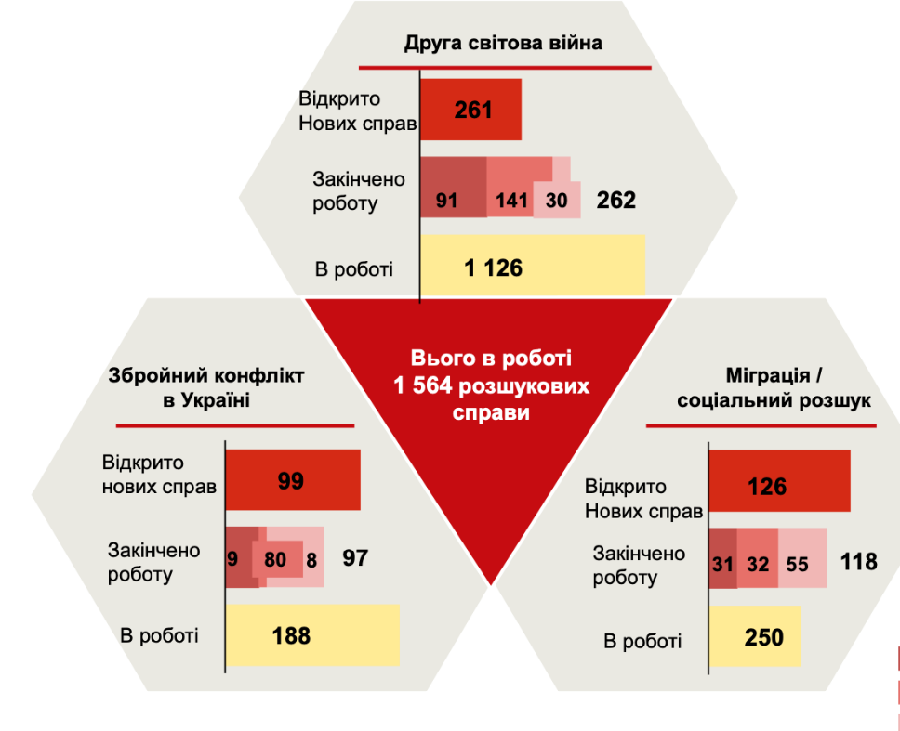

World War II

- 261 new cases opened
- 91… cases completed
- 1,126 ongoing cases

Armed conflicted in Ukraine

- 99 new cases opened
- 9…. cases completed
- 188 ongoing cases

Migration/ Tracing Service

- 126 new cases opened
- 31…. cases completed
- 250 ongoing cases

Owning to the ongoing armed conflict in Ukraine, in the reporting year the Tracing Service staff worked quite intensively with requests from family members of the missing.

• According to the established criteria of the International Committee of the Red Cross Society and the Ukrainian Red Cross Society, work was continued on 188 cases.
• Under the grant support program of the International Committee of the Red Cross Society 71 applications (16 for training; and 55 multi-purpose grants) were submitted to the ICRC. Monitoring of grants receipt by families was conducted.
• Documents for treatment assistance were collected from 4 families for participation in the ICRC health care program.
• Families of the missing persons (beneficiaries of the URCS Tracing Service) were also supported within the programs implemented by the URCS regional organizations: 3 families received farming vouchers in Zaporizhia, all families in Kharkiv received humanitarian kits within the emergency response program; 1 family in Lviv wass permanently provided with medicines within the program.

Response to psychological and social needs of family members of the missing:

• Support was provided in solving social and administrative issues: referral (institutions in the region); use of "office" opportunities, assistance in drafting applications to local authorities (Kharkiv); needs assessment and collecting of information from the city administration (Kryvyi Rih).
• Group meetings with families in Lviv (January 2020) and Kharkiv (March 2020) were organized, and initial contacts with families were established for individual meetings within the ICRC Mental Health and Psychosocial Support (MHPSS) Program.
• Communication with families within the framework of the program "We Are Close": 1,335 phone calls and supportive contacts via Viber, as well as 99 personal meetings.
• Excursion travel to Svyatogorsk Lavra was organized for families from Kharkiv region.

Implementation of "Restoring Family Links for Detained Migrants in Ukraine" program in conditions of COVID-19 (Zakarpattia, Volyn and Chernihiv regions).

In view of quarantine measures in Temporary Detention Centres for Migrants (TDCM), the format of work was changed:
- visits to migrants detention places were temporarily suspended
- telephone units for RFL were handed over to directors of detention centres for the time of quarantine restrictions to allow migrants to contact their relatives
- constant contact maintained with focal staff of the Centres for monitoring the detainees' access to means of communication with family members, RFL, and other humanitarian needs of migrants
- for disease prevention the Society’s information materials on COVID-19 were distributed to the detainees
- for prevention of coronavirus infection spread among the detained migrants, personal protective equipment was purchased with the ICRC’s financial support and the Ukrainian Red Cross Society’s reserves,: 3,000 pairs of gloves, 1,723 masks, and 15 litres of disinfectant.

During the reporting period, there were made 418 calls to family members for restoring family links, 17 requests to counsellors for documents restoring and expedited return of detained migrants to their homeland.

The work done contributed to the uninterrupted needs satisfaction of detained migrants regarding the restoring family links at a time of quarantine restrictions.

Also, 430 of the most vulnerable migrants received humanitarian assistance from the Ukrainian Red Cross Society.

In 2020 the promotion of the Tracing Services activities continued. During the reporting period, publications on various topics (current cases, statistics, activities of regional organizations, cooperation, thematic meetings, RFL for migrants) were published on the Society's website and official pages on social networks.

At the regional level the local information resources were regularly used in the regions where the Tracing Service staff personnel worked.

Every year on August 30, the International Red Cross and Red Crescent Movement joins commemoration of the International Day of the Disappeared. On this day, in many countries the events are held to preserve the memory of those whose fate is still unknown. Hundreds of thousands of people, whose relatives have disappeared, from all parts of the world unknown to each other but with the same pain, share their grief, support each other and cherish a hope together on August 30.

Each year on 30 August the Ukrainian Red Cross Society reminds of the right of family members of the missing to know the fate of their relatives, that is one of the main provisions of international humanitarian law and human rights. It operates regardless of when and under what circumstances a person went missing: during a war, armed conflict, natural disaster or migration. We must not forget about these people.

For the International Day of the Disappeared in coordination with the International Committee of the Red Cross (Kyiv and Sloviansk):
- thematic posters were developed together with the International Committee of the Red Cross, and 80 posters were placed in 11 regions of Ukraine
- All-Ukrainian thematic flash mob was organized and held
- 142 families of the missing were contacted throughout Ukraine
- information campaigns held in the main city squares (Dnipro, Lviv, and Uzhhorod)
- in Donetsk region the joint actions and events with the International Committee of the Red Cross Sloviansk Office were held
- information stream was organized on web resources of the National Committee and regional organizations of Ukrainian Red Cross Society
- a prayer in Lviv organized and a prayer with family members in Dnipro visited

Thus, efforts were made to reach a wide range of population belonging to RFL potential beneficiaries.

Following the framework of the new Movement RFL Strategy and based on the strategic goals on development of the Movement tracing services up to 2025 and taking into account the context of RFL needs in our country; the priorities of the Tracing Service in 2020 were:
• capacity strengthening for implementing the RFL activities at the regional level through training and retraining of employees and volunteers of subordinate organizations
• further psychosocial support for families of the missing
• continued work with tracing requests related to the consequences of the World War II and in favour of detained irregular migrants, given the significant needs for such search in our area.
• use of various resources focused on different target audiences and quality improvement of information support of the Tracing Service’s activities in order to ensure continuous presence of information about URCS’ RFL services in the media space and prevent family separation/loss of family links
• use of modern technologies, which are effective in the Global RFL Network, and effective partnership with the International Movement partners to provide RFL assistance to the Tracing Service beneficiaries

• support of interaction and cooperation with the interested state authorities and NGOs both at the central and regional levels.

HEALTH CARE PROGRAMS AND DIRECTIONS

Mobile Medical Units

Assistance to internally displaced persons

From the first days of the armed conflict in the country, the Ukrainian Red Cross Society under its mandate has been assisting internally displaced persons from the Autonomous Republic of Crimea, Donetsk and Luhansk regions. Since 2014 until present, humanitarian assistance was provided to more than 1 million internally displaced persons.

In total the Society provided humanitarian support to those affected by the armed conflict in eastern Ukraine and other vulnerable populations to the amount of more than 1 billion UAH, including support to medical facilities worth 109 million UAH. In 2015-2020, four Mobile Medical Units (MMUs) worked along the line of contact and assisted more than 100,000 patients deprived of medical services due to the armed conflict.

Each MMU is equipped with a specialized vehicle, portable electrocardiograph, and blood glucose and blood pressure meters. Several units have portable ultrasound systems.

MMU activities in remote villages of Luhansk and Donetsk regions along the line of the armed conflict were implemented in 2020 within the joint project with the Austrian Red Cross " Restoring Livelihoods and Meeting Basic Health Needs in Donetsk and Luhansk Regions through Sustainable and Gender-Sensitive Interventions" funded by the donor organization Austrian Development Agency, total project value – 452,907 EUR, implementation period – 15.12.2019 - 14.06.2021.

In 2020, the URCS Mobile Medical Units operated in 35 locations of Novoaidar and Popasna districts of Luhansk region (including 4 red ones) and 15 locations of Bakhmut and Toretsk districts of Donetsk region (including 2 red ones).

MMU activities were carried out under the Memoranda of Joint Activities between the regional organizations of Ukrainian Red Cross Society and regional health departments and primary care centers.

MMU worked by the new comprehensively updated algorithm for management and logistics within conditions of a decentralized system of medicines and medical supplies procurement, with maximum involvement of medical staff of the primary level public health care service in planning and joint reception of patients at feldsher's stations in the locations.

The COVID-19 Response

Starting from March 23, 2020, when quarantine restrictions were officially announced in Ukraine, MMU staff switched to remote patient support and provided phone consultations to patients and population on basic rules of behaviour during the coronavirus epidemic. In total 2,845 phone consultations were delivered by the MMU staff during the period of remote work.

From May 25, 2020, MMU returned to regular site visits to locations with specialists of the primary medical and sanitary centres of district subordination. To ensure the epidemic safety, the MMU personnel received special reusable personal protective equipment. Regarding the medicines and medical supplies procurement the special emphasis was placed on purchase of personal disinfectants, and briefings on their proper use were conducted for staff and patients at feldsher’s stations.

As this project is based on the age and gender sensitive approach, its special part was devoted to raising awareness of staff and communities in recognizing and responding to gender-based violence, and about the Ukrainian Red Cross Society’s approach on community engagement and accountability (CEA) with a focus on community engagement in the COVID-19 response and feedback mechanisms.

In view of quarantine restrictions, the relevant online training for employees of Luhansk Regional and Kostiantynivka City District Organizations of Ukrainian Red Cross Society were conducted.

As a result of the training on gender-based violence and the community engagement and accountability (CEA) webinar the participants gained knowledge on:

- Gender issues and their impact on the phenomenon of violence.
- Gender-based violence, its types, and consequences.
- Relevant legislation, system of assistance in Ukraine.
- Peculiarities of victim’s condition and work with them by medical staff.
- Gender-sensitive approach in implementation of humanitarian programs.
- The importance of community engagement and accountability (CEA) approach.
- Risk awareness and community engagement in the COVID-19 response.
- CEA and community feedback system.

Besides, in 2020 the first independent expert evaluation of the project "Multisectoral Support for Internally Displaced Persons and Local Population in Luhansk and Donetsk regions" was conducted with support of the National Committee of Ukrainian Red Cross Society. For this important task the competition for evaluation staff selection was held in March-April, and 6 experts were selected (3 from the project’s medical component, and 3 from the project’s grant component).

Under strict quarantine conditions, the experts carried their work via remote communication means with beneficiaries and all project implementors at the central and local levels. This did not prevent them from the comprehensive expert evaluation of the project results, moreover the report was highly praised by customers and professionals of the area.

Provision of Professional Medical Care by Mobile Units in Donetsk and Luhansk Regions (number of patients)

Women | Men | Children | Displaced persons | Disabled
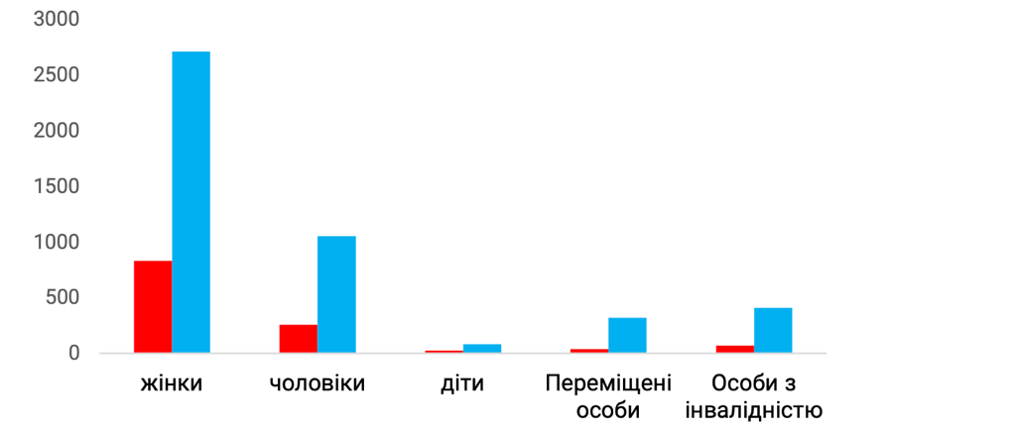

Donetsk region | Luhansk region

MMU Medical Care Indicators (number of patients)

Donetsk region Luhansk region

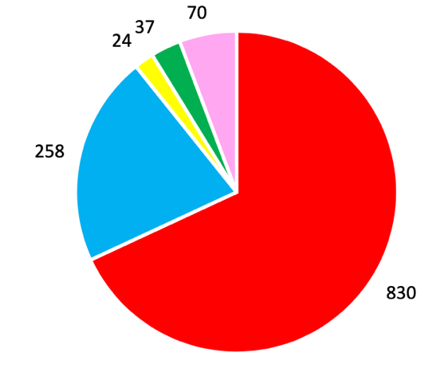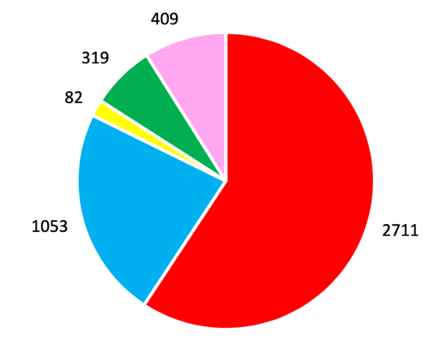

Women | Men | Children | Displaced persons | Disabled

Visiting Nurses Service

Ukrainian Red Cross Society has been providing medical and social support to population for over 55 years. Despite the suspension of centralized state funding of the Visiting Nurses Service, the Society maintains its activities through cooperation with partners and local authorities.
The Visiting Nurses Service activities are carried out in 10 regional organizations (Luhansk, Chernihiv, Volyn, Zhytomyr, Poltava, Kherson, Donetsk, Mykolaiv, Lviv, and Zakarpattia). The Visiting Nurses Service activity is financially supported from budgets of united territorial communities (UTC), district, city and settlement budgets, and employment centres.

In Donetsk and Luhansk regions, the Visiting Nurses Service activities are supported by the International Committee of the Red Cross Society. 60 nurse positions working under civil law contracts are funded.
In Lviv 5 nurse positions are funded by the Baden Red Cross.
In Zakarpattia region, 21.25 nurse positions are financed by KRK-Ukraine and the Charitable Foundation “Dim Myloserdia”.
In Mykolayiv and Volyn regions volunteers are also involved in taking café of beneficiaries.
For 11 months, the Visiting Nurses Service provided care to 1,391 people throughout Ukraine.

Beneficiaries of the Visiting Nurses Service include lonely or living alone older people, disabled persons with limited mobility, who live far from the infrastructure. They are provided with social and domestic services at home: assistance in cleaning the dwelling, cooking, food and medicine delivery, and minor repairs. Beneficiaries are also accompanied to medical facilities, assisted during a walk, applying for a subsidy, utilities payment, etc. Hygienic services are provided for people with limited mobility, including bedridden persons.

Medical and Social Support for Tuberculosis Patients

Successful treatment of tuberculosis requires continuous adherence to therapy and encouragement of patients to follow a treatment regimen.

Ukrainian Red Cross Society's activity on fighting tuberculosis covers several directions.

For the World Tuberculosis Day the funding was received from the International Federation of Red Cross and Red Crescent Societies for informational and promotional materials printing and children’s drawing competitions. 5,469 people were covered by information events. Categories: schoolchildren, students, members of the Society's Active Longevity Clubs, beneficiaries of the Society's Visiting Nurses Service, other categories the Society's beneficiaries, internally displaced persons, volunteers and employees of the Society, and general population. Ukrainian Red Cross Society organizations held drawing competitions for children on the topic of fighting tuberculosis. 383 children participated.

The Society's organizations provide charitable assistance to tuberculosis patients from the vulnerable populations (clothing and footwear, food, etc.) within their possibilities.

7 regional organizations (Volyn, Donetsk, Luhansk, Kherson, Kyiv, Mykolaiv, and Zakarpattia) implemented the project supported by the Global Fund to Fight AIDS, Tuberculosis, and Malaria through the Public Health Alliance and Charitable Association "100 Percent of Life".

Thus, Kyiv Regional Organization of Ukrainian Red Cross Society together with social workers have already supported more than 300 people in the outpatient treatment of tuberculosis in Kyiv region within the project "Provision of Medical and Social Support for Patients with Tuberculosis".

During the last two months the project has been presenting the positive results:

• 200 new patients joined the care program
• about 700 food kits were distributed to support patients undergoing outpatient tuberculosis treatment
• more than 100 patients received mobile communication support
• about 60 patients receive medicines for treatment at home thanks to support of DOT providers; others visit the DOT offices of outpatient department;
• more than 20 patients are accompanied for additional medical examination (CT, MRI, etc.);
• support of DOT providers and patients with personal protective equipment, antibacterial soap, hand sanitizers and gloves.

Two regional organizations (Poltava and Kherson) participate in the PATH project (supported by the USAID).

During the reporting period, 3,325 people received services on care under the above-mentioned projects.

The projects provide medical and social support (arrangement of controlled medication intake, side effects management, timely visits to doctor and undergoing tests, etc.) and socio-psychological support (motivation for completing the treatment, responsible attitude to health, work with patient's environment, etc.). The project beneficiaries include tuberculosis patients at high risk of interrupted treatment, people in difficult life circumstances, and people with drug and alcohol addictions.

Ukrainian Red Cross Society participates in the Partnership "Stop Tuberculosis. Ukraine" and is a member of the National Council on HIV/AIDS and Tuberculosis.

Donation of Blood and Its Components

The Ukrainian Red Cross Society’s organizations works closely with regional blood service centres and their local offices, district blood transfusion departments, government agencies (departments for family, youth, and sports), non-governmental organizations, higher education institutions, and organizations.

Regular activities for donors engagement are carried out (3,671 people were attracted in 2020).

Honorary donors, activists, and blood donation advocates are regularly awarded (25 events held, 1,372 people received charitable assistance and social support). During the reporting period, at least 33 events were conducted to promote the blood donor movement, including more than 100 publications in the media and social networks.

In order to promote blood donation and replenish blood shortages in medical facilities due to increased quarantine restrictions and risks of the COVID-19 spread, the following actions for blood donors attraction were organized and implemented jointly with partner organizations within the framework of the COVID-19 response:
- joint blood donation of the Ukrainian Red Cross Society’s employees and volunteers and representatives of the Armed Forces of Ukraine (300 people)
- joint blood donation of the Society’s employees and volunteers and film production workers and actors (15 people)

- joint All-Ukrainian Action of the Ukrainian Red Cross Society and the Ministry of Youth and Sports of Ukraine with support of Ogilvy Ukraine Advertising Agency "Victory is in Our Blood" for blood donors attraction from among professional athletes and general population (currently 7,850 people, but the action is ongoing).

Psychosocial Support

During 2020 the psychosocial support activities underwent significant changes due to the coronavirus pandemic, because the community level psychosocial support (mostly provided by the Ukrainian Red Cross Society) involved group work. Nevertheless, most of the Society's interventions included psychosocial support (PSS) or psychological first aid (FFA) in response to the significantly increased stress and anxiety experienced by the Ukrainian population in the conditions of volatile epidemiological situation.

Community Level Psychosocial Support

In 2020 the community level psychosocial support was delivered in 8 regions of Ukraine (Donetsk, Luhansk, Mykolaiv, Kherson, Vinnytsia, Lviv, Ternopil, and Kyiv regions) with the financial support of the Danish Red Cross through the project "Promoting Protection, Well-Being and Social Cohesion for Vulnerable Groups in Ukraine" and partly at the organization's own expense (Bila Tserkva City District Organization, after completion of the project in Kyiv region in the second quarter of 2020).

PSS sessions were adapted to quarantine restrictions: with the use of personal protective equipment, antiseptics, as well as holding of the most activities outdoors, which allowed to cover the following number of unique beneficiaries:
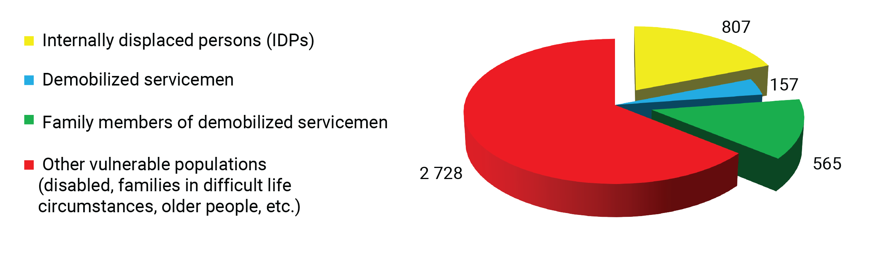
In addition to psychosocial support group sessions 134 residents of settlements along the demarcation line in Donetsk and Luhansk regions were trained in psychological first aid within the project "Reducing Disaster Risk Vulnerability in East Ukraine".

Response to the COVID-19 Outbreak:

Following the Resolution of the International Red Cross and Red Crescent Movement on addressing psychosocial needs of December 2019, the Ukrainian Red Cross Society included PSS or first psychological aid components in its interventions on the coronavirus pandemic response.

Thus, the Society distributed psychosocial support kits together with hygiene kits to families with children and single (living alone) older people. The kits were purchased within the projects "Support to the Ukrainian Red Cross Society’s COVID-19 Preparedness and Response (HumFlex)" and "Preventing the Spread of and Responding to COVID-19 in the Eastern Conflict Areas, Ukraine (OFDA-COVID)":
• 2,015 kits for families
• 1,660 kits for older people

The main idea behind the kits for families with children was to reduce the level of the pandemic related stress (first of all among children), enhance the family cohesion and facilitate the family relations improvement. The kits for older people were also intended to reduce stress and anxiety, and support cognitive functions.

The kits were distributed together with the information materials: posters for the older people, children's books, and brochures "How to Support the Close Ones during Isolation".

The kits distribution was followed by the relevant evaluation (phone survey of beneficiaries who received kits), which showed significant satisfaction of the beneficiaries: 96.3% of the surveyed older persons were completely satisfied with the kit’s composition (rated 10 out of 10), the corresponding index among the families with children was 85.7%.

The kits distribution was implemented together with online sessions for population. Main regional and district psychosocial support specialists were provided with all necessary equipment and methodological support, including recommendations on online platforms use for group sessions, which were developed by an external specialist in online learning. The sessions with creativity and the Program for the Emotional Resilience Development of Children, adapted to the online format, were the most popular ones.

Moreover, a significant number of master classes were recorded on video and published on free platforms. In April-November, 5,789 services were provided (for online services, session attendance and video views were counted, but not unique beneficiaries, due to technical impossibility of the participants registeration by name).

In addition to basic psychosocial support, the Society has launched the support line "Let's Talk" for medical staff, rescuers and other supporting professions in Donetsk and Luhansk regions. In August-November, the call operators processed 3,743 calls.

Ukrainian Red Cross Society also became a partner of Tell Me Platform, which was established by the Institute of Cognitive Modelling in cooperation with the Ukrainian Red Cross Society and the Ministry of Health of Ukraine to provide free psychological support to population of Ukraine. The Society provided informational support to the platform through outdoor advertising and compensation to the most active volunteer psychologists. As of the end of August, 2,230 applications were registered on the platform, most of which were responded or being in progress.

The Society additionally distributed information materials on psychoeducation and response normalization among the population. 20,000 posters with psychosocial self-care advice for doctors were distributed in hospitals throughout Ukraine. Also, 2,500 Isolation Diaries were published and distributed through family doctors.

The book "My Hero is You" was specially designed to support children during the pandemic. The books were distributed to children's institutions, and adapted into an audio format.

Volunteers and Staff Training

Total number of volunteers in PSS teams was 249 people.

In 2020, 22 training on Psychological First Aid (PFA) and Basic Psychosocial Support took place. As a result of them 230 volunteers and employees from different directions (including emergency response teams and home visiting nurses) practiced the crisis support skills. Also, all operators of the Ukrainian Red Cross Society’s Information Center were trained to provide remote PFA in under the COVID-19 conditions.

In 2020, Mariupol Emergency Response Team established the Psychological First Aid Unit, which consisted of 7 volunteers, all trained in PFA, and three of them being PFA instructors. To support the unit, in 2020 the funds were allocated to purchase materials for crisis response and psychological first aid.

During 2020, also there were conducted the national trainings:
• Experience sharing workshop on psychosocial support (Kyiv, August) – 18 participants
• PFA Instructor Training (Mariupol, September) – 10 participants

Caring for Volunteers and Staff

In addition to regular care measures for volunteers and staff, which were continuously implemented by regional organizations, in 2020 the Ukrainian Red Cross Society has launched the free psychological support service for volunteers and staff in the period of the COVID-19 response activities (and, consequently, increased workload).

Under the agreement with Kyiv Institute of Modern Psychology and Psychotherapy, the support service for the Society's volunteers was established. Volunteers could apply for consultation to a qualified specialist. The service worked from May to October, and 413 consultations were provided during this time.

Humanitarian Education

In 2020 the humanitarian education was finally shaped in a separate activity direction of the Ukrainian Red Cross Society. Humanitarian education combines education programs and activities that enable people (especially the youth) to overcome daily challenges based on the Fundamental Principles and humanitarian values of the International Red Cross and Red Crescent Movement.

Humanitarian Education, as the unique activity direction of the International Red Cross and Red Crescent Movement, was established by the International Federation of Red Cross and Red Crescent Societies in 2010 and combined educational activities including international humanitarian law (IHL) and mine risk awareness. At the initial stage of the humanitarian education development in the Society, it would be focused on:
• establishing of a culture of peace and non-violence (self-care and care for others) through emotional and social intelligence development
• social tension reduction, violence and discrimination prevention
• establishing of a culture of social inclusion and respect for diversity
• active citizenship and participation in community life and development

Translation of the term Humanitarian Education into Ukrainian was a special challenge, because in Ukrainians' minds and vocabulary the word "humanitarian" is firmly attached to the humanitarian, i.e. social sciences (humanities) – philology, philosophy, history, law, art history, psychology, etc., and humanitarian aid in the meaning of free provision of essentials and food products to vulnerable populations or disaster victims. However, from among the possible options "гуманістична освіта", "гуманна освіта", "освіта гуманності" the most accurate translation "гуманітарна освіта" was chosen, because all over the world, the main meaning of the word гуманітарний/humanitarian is “imbued with humanism, concern for human welfare, and respect for human dignity”. For the Society as the largest humanitarian movement in Ukraine, the stamping on the Ukrainians’ minds of such interpretation is a fundamental task in the coming years.

The main thematic blocks of humanitarian education:
• Behavioural Changes: the programs Youth as Agents of Behavioural Changes (YABC), and Life Skills, and the course Conflict Resolution and Nonviolent Communication
• Active Citizenship: School of Social Initiatives, methods of social projects development and implementation Sprint;
• Humanitarian Leadership: the courses Leadership, and Mentoring, and the program Humanitarian Diplomacy and Advocacy
• Adaptation to Climate Change

For the humanitarian education development within the Ukrainian Red Cross Society during 2020, 5 large-scale projects were written, 2 of which were supported and have being already implemented.

Youth Leaders of Ukraine Project

The project aims to develop the youth leadership and volunteer teams in Ukraine. It empowers the youth to actively participate in shaping and changing their communities through social initiatives and engagement in the life of society.
The project will be implemented in 2020-2021 in Kharkiv region (Kharkiv, Kupiansk, Krasnohrad) and Dnipropetrovsk region (Dnipro, Kryvyi Rih, and Pavlohrad).

Our project partners are the Danish Red Cross, Danish Youth Red Cross, Ministry of Youth and Sports of Ukraine, NGO Ukrainian Academy of Leadership, NGO Ukrainian National Youth Council, the Commissioner of the President of Ukraine for Volunteering Affairs, and the All-Ukrainian Youth Center.

• The project’s information campaign with the slogan "Volunteering is your PLUS" for fill the "red cross" symbol with new meaning and added value has reached more than 200,000 people.
• An in-depth project participants recruitment and selection system was developed and tested (18 participants out of 65 candidates).
• 5 trainers were trained and certified in methodology for social projects developing and implementing "Sprint".
• The unique 6-day training "The Youth Leader Path: Red Cross Formula" was developed and conducted for 18 young boys and girls in partnership with the Danish Red Cross Youth and the Ukrainian Leadership Academy.
• 8 Sprint workshops for 51 participants held
• 16 projects and social initiatives have been developed and already launched
• The project topics were: first aid, emotional intelligence development, prevention of drug and alcohol abuse, gambling and video game addiction, creation and fit out of youth spaces, bicycle trips for family strengthening, support for boarding school graduates, media literacy for the youth, and ecology in practice
• 82 volunteers engaged in volunteer teams
• 137 events held
• 3,441 beneficiaries covered by project activities

Active Youth for Safer Schools Project

The project goal is to increase safety in schools by engaging the secondary school youth in the school communities’ development. The project develops personal and interpersonal skills of high school youth, teaches them to create social projects on "How can I improve my school community's life?", ensures and supports their implementation.

The project will be implemented during 2020-2021 in 8 settlements of Donetsk and Luhansk regions.

Our partners are: the International Committee of the Red Cross, Danish Red Cross, and the Danish Red Cross Youth.

The project administrative and methodological work started in December 2020.

YABC Program – Youth as Agents of Behavioural Changes

• In 2020, the YABC program (Youth as Agents of Behavioral Changes) has been transferred for coordination under the humanitarian education.
• The term "наставник YABC" has been changed to "рівний інструктор YABC" as more precise translation of the English term YABC peer educator.
• 26 new peer instructors trained
• 13 peer instructors completed a refresher workshop
• As of 2020, the YABC network covers 17 regions: Kherson, Ternopil, Lviv, Kyiv, Vinnytsia, Mykolaiv, Donetsk, Luhansk, Dnipropetrovsk, Zaporizhzhia, Zhytomyr, Kharkiv, Poltava, Sumy, Zakarpattia, Rivne, Chernihiv regions and Kyiv city.

• 760 beneficiaries of YABC sessions in total, among them:

Kyiv regional organization
Kharkiv regional organization
Lviv regional organization
Kherson regional organization
Mykolaiv regional organization
Vinnytsia regional organization
Ternopil regional organization
Luhansk regional organization
Donetsk regional organization
Sumy regional organization
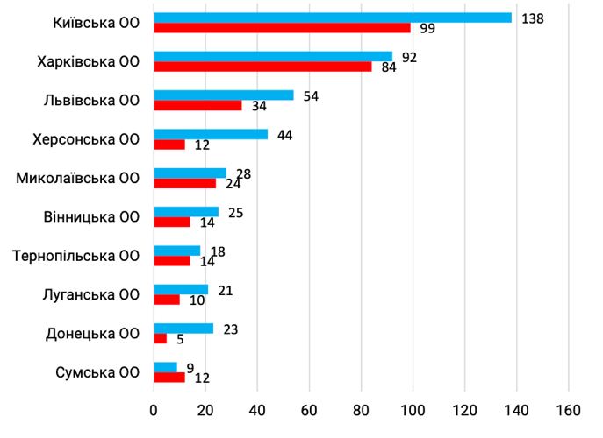
Male | Female

• The ongoing support for the YABC peer instructors has been established through online meetings every two weeks (7 meetings have been held).
• YABC basic methodological materials for program development translated into Ukrainian.
• trainers from Ukraine participate in the YABC multinational expert team for development of an online methodology by program;
• The Ministry of Youth and Sports of Ukraine invited the YABC program to all state youth centres of Ukraine (the start of cooperation was postponed due to quarantine restrictions).
• Development of teaching capacity, monitoring and evaluation of program outcomes were identified as priorities for 2021.

Conflict Resolution and Nonviolent Communication Course

In 2020, the course was selected as one of the prospective activities of Ukrainian Red Cross Society:
• 39 volunteers and employees of the Society completes the 4-day course
• working group for the direction development created consisting of 2 trainers, 3 co-trainers and 1 assistant, who met every month on average
• methodology of conducting one-day training and short thematic sessions based on the course materials was developed
• short sessions on the course were held at 4 regional volunteer assemblies for more than 100 volunteers
• workbook for keeping course materials and systematization of ideas was developed for participants
• creation of the Society's teaching capacity, monitoring, and evaluation of the course’s results were identified as priorities for 2021

Humanitarian Diplomacy and Advocacy Program

• 2020 was the year of extensive consultations with the Danish Red Cross and the Finnish Red Cross, capacity exploration and program development planning.
• The partnership with the NGO "Centre for Democracy and Rule of Law" and the National Youth Council of Ukraine has been established in the field of advocacy.

• Humanitarian education, youth engagement, and social cohesion were chosen the primary goals for the advocacy tools testing.
• 1 volunteer and 1 employee of the Society completed the training courses "Humanitarian Diplomacy" of the International Federation of Red Cross and Red Crescent Societies and DiploFoundation, and "Advocacy" of the NGO "CEDEM".
• In the framework of cooperation with the Ministry of Youth and Sports of Ukraine, the Society’s volunteers and employees provided recommendations to the National Strategy for Youth Policy Development 2020-2030, and in the framework of cooperation with the Commissioner of the President of Ukraine for Volunteering Affairs recommendations to the concept of creating the National Alliance of Volunteers were prepared.
• Advocacy has been identified as one of the priority areas for development by the Ukrainian Red Cross Society’s Strategy 2021-2025.

School of Social Initiatives Program

• The program was conducted in 6 schools (Kupiansk, Ternopil, Kryvyi Rih, Odesa, Mariupol, and Lviv), including 2 online programs (Mariupol and Lviv).
• 11 projects were developed and are being implemented.
• project topics were aimed at psychosocial support, social cohesion, motivation of volunteers, and burnout prevention.
• In 2020, 96 volunteers took part in schools of social initiatives and implemented mini-projects for almost 900 beneficiaries.

Adaptation to Climate Change Program

In 2020, the base was created and the necessary resources generated for establishment of the Humanitarian Education Department in 2021.

The program was launched in the end of 2020 to conduct the relevant research on the topic.

INFORMATION ACTIVITY

International Humanitarian Law

One of the Ukrainian Red Cross Society’s activity directions is the dissemination of knowledge about international humanitarian law (IHL), cooperation with the Government, and international organizations to ensure compliance with the IHL regulations and protection of the Emblems of the International Red Cross and Red Crescent Movement.

IHL Activities

During 2020, nine events on international humanitarian law were held (workshops, introductory sessions, training) reaching about 220 participants. Also, with support of partners, two online workshops were held for the Armed Forces of Ukraine and the prosecution authorities covering 80 participants.

At the beginning of the year, the National Congress of International Humanitarian Law Trainers was held, during which participants discussed current IHL topics and shared joint experiences.

In the autumn 2020, the cooperation with chaplains of the Armed Forces of Ukraine was launched. The first IHL workshop for military chaplains was held, which was the international humanitarian law workshop for military chaplains of various religious denominations.

Protection of the Emblems of the International Red Cross and Red Crescent Movement

In 2020, volunteers and employees of the Ukrainian Red Cross Society recorded about 28 cases of violations of the emblems use, 13 of which were successfully resolved.

This year, for the first time during the Ukrainian Independence, a court decision was made, which stopped the illegal use of the Red Cross emblem.

On November 3, 2020, the decision was made by the Commercial Court of Zhytomyr region thanks to efforts of experts of the top law firm in Ukraine "Illyashev and Partners".

For a long time, one of the big networks of medical centres in Ukraine used in its activities the image of red cross on a white background as its own trademark, placed it on the signs of their medical institutions, on websites, in advertising campaigns and documentation. Such use of the emblem is violation of the laws of Ukraine "On the Ukrainian Red Cross Society " and "On the Symbols of the Red Cross, Red Crescent, and Red Crystal in Ukraine."

Unlike other charitable organizations, the Ukrainian Red Cross Society has a special mandate, owns humanitarian initiative, as a member of the International Red Cross and Red Crescent Movement, operates based on the above laws, which grant the Society and its representatives in Ukraine the right to use image of a red cross.

It should be noted that Illyashev & Partners Law Firm represented interests of the Ukrainian Red Cross Society in court Pro bono (on voluntary base and free of charge).

From now on, the network of medical institutions has stopped the illegal use of the Red Cross emblem.

The work has begun to engage law students in protection of the Emblems of the International Red Cross and Red Crescent Movement and promote the IHL direction among the students.

In 2020, the three-year project on IHL development within the Society, which was supported by the Finnish Red Cross, came to an end. By the project training program, there were trained 35 trainers, who conduct IHL activities and disseminate knowledge among the Movement volunteers and civil population.


Within the project, an IHL introductory video was created for the general public in 2020.

Work on IHL promotion on the social network Facebook was carried out; the group "IHL Ukraine" was created to cover the latest IHL news and unite all people interested in IHL. As a result, the number of group members increased by 34%, and the number of people wishing to attend IHL events and willing to become IHL trainers increased sharply.

A working group has been set up to develop the IHL manual for trainers. The manual contains the main IHL topics and identifies target audiences that are potentially most interested in the IHL study. The manual will provide trainers with a clear algorithm of work during the activities, exercises for work with the audience and will allow to avoid difficult questions from the participants to which the trainers might not answer due to the qualification level.

The further long-term cooperation with the National Aviation University has been launched, and the first IHL club for international law students of the International Law Department has been established.

• In the framework of the launched cooperation with chaplains of the Ukrainian Greek Catholic Church the online workshop was held for 60 chaplains. The event provided an opportunity to further spread the IHL knowledge among a significant number of chaplains and the military staff of the Armed Forces of Ukraine.

• Canadian Red Cross has joined the Joint Action Plan 2021 of the Society, Danish Red Cross and the International Committee of the Red Cross.

Mine Risk

Since July 2015, the Ukrainian Red Cross Society with the support of the International Committee of the Red Cross has been implementing a project to reduce the risk from mines and explosive remnants of war.

The main project objective is to raise awareness of vulnerable populations about the threat posed by mines and explosive remnants of war. Efforts were focused on the informing of residents of settlements in the conflict zone and the internally displaced persons.

The most effective tool for communicating the knowledge is to work with local communities who are ready to spread knowledge about the danger and safe behaviour. Frequently they are teachers of local schools, staff of the Society and the State Emergency Service of Ukraine, and volunteers of various humanitarian organizations.

In 2020, 541 information sessions were held, particularly in 319 in Luhansk region, and 222 in Donetsk region. Within the framework of the program "Safer Behaviour/ Raising Awareness about the Risks of Explosive Remnants of War" a training was held for 16 future instructors. In the end of 2020, there were 25 instructors in total in the above-mentioned regions.

Main Achievements:

1. 5,134 beneficiaries were informed and trained in safe behaviour.

2. Printed stickers layout for school children was developed and approved. The online training package was adapted.

3. 3 instructor training for were conducted, 2 of which were arranged online.

4. In September 2020 together with Mariupol Office of the International Committee of the Red Cross the mine safety field exercises were held for volunteers and staff of Volnovakha, Marianka and Mariupol Organizations of the Society.

Data collection on mine and ammunition incidents is carried out regularly. This allows you to focus work in the priority districts and adjust the information provided at the education sessions.

Cooperation and International Relations

Protection Cluster

In 2020 the Ukrainian Red Cross Society became a partner of the Protection Cluster, that also helped to increase our capacity and make a statement.

The Protection Cluster (hereinafter referred to as “the Cluster”) is one of the most active clusters. It includes both national and international organizations. Conflict related protection needs are paramount in the country. As a Cluster partner, the Society has the opportunity to learn and capitalize experience (of other partner organizations), expand the communication network, and improve available opportunities. Our visibility in the Cluster (meetings, reporting, etc.) increases the Society’s capacity on resources mobilization and partnerships building.

The Society submits information in 5W forms quarterly to stay the Cluster partner. As of 2020, reports were submitted in the following areas: YABC, social cohesion, mine risk awareness and information dissemination, mine education, psychosocial support, and international humanitarian law.

Besides, the Society's information has been repeatedly included in the Protection Cluster’s briefing note that increases our visibility for the United Nations Office for the Coordination of Humanitarian Affairs (UN OCHA) and other international organizations. Ukrainian Red Cross Society also provided monthly information to the Protection Cluster following the COVID-19 5W form, and the UN Office for the Coordination of Humanitarian Affairs (UN OCHA) included it to the information platform.

Main Achievements on the Protection:

• In August 2020, Ukrainian Red Cross Society has adopted the Child Protection Policy, which was created based on the Child Protection Policy of the International Federation of Red Cross and Red Crescent Societies with consideration of the Ukrainian legislation on child protection, international standards "Sphere" and the UN Convention on the Rights of the Child. On the basis of the Child Protection Policy the information posters were developed and distributed to regional and local organizations of the Society.

• Based on the Gender Policy of Ukrainian Red Cross Society, which was adopted in December 2019, the most frequent questions and gender alphabet were developed and collected into in a brochure to be shared with the staff (employees and volunteers) of the Society.

In 2020:

• finalization the Personal Data Protection Policy and the Feedback Policy
• feedback boxes together with information posters have been distributed to local organizations
• 2 practice seminars were held by methodology of the Canadian Red Cross,"10 Steps to Creating Safe Environments", for Podil District Organization in Kyiv city and the Emergency Response Team of Mariupol local organization. 21 people attended the seminar.

During the year, the coordination and communication with the International Red Cross and Red Crescent Movement partners were constantly implemented: the International Federation of Red Cross and Red Crescent Societies, the International Committee of the Red Cross, Swiss Red Cross, Danish Red Cross, Austrian Red Cross, German Red Cross, Finnish Red Cross, French Red Cross and Luxembourg Red Cross.

Funds Raised by the Cooperation and International Relations Department for the COVID-19 Response

Data in UAH

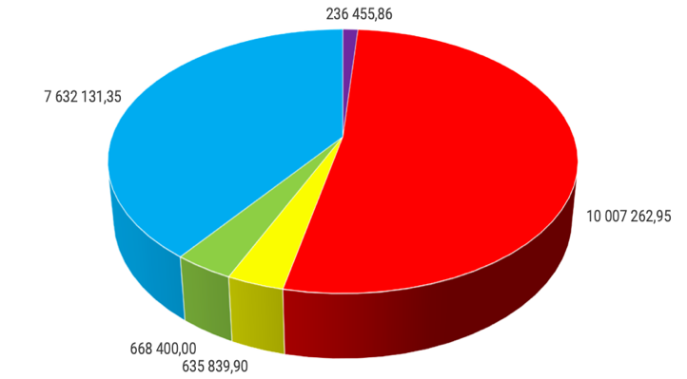

charitable funds attracted with support of partner organizations
charitable funds attracted from strategic corporate partners
assistance in kind
funds raised by the Department of Cooperation and International Relations for response to floods in Western Ukraine
humanitarian assistance attracted in 2020

Memoranda Signed in 2020

- State sector: the Ministry of Youth and Sports of Ukraine, the Ministry of Veterans of Ukraine, the Armed Forces of Ukraine, the Ministry of Health of Ukraine (within the framework of the joint awareness campaign for fighting COVID-19), the Public Health Center of Ukraine, and the Commissioner of the President of Ukraine for Volunteering Affairs.

- New Movement Partners in 2020: Turkish Red Crescent and Italian Red Cross.

- Strategic corporate partners: StarLightMedia Media Group, Ogilvy Ukraine Advertising Agency, scientific and research company Institute of Cognitive Modelling, Jokers.film Production Group, and Kercher LLC.

Support and coordination were provided under the joint media campaign on the COVID-19 prevention of the Ministry of Health of Ukraine, Ukrainian Red Cross Society and StarLightMedia. About 26,000,000 people were reached.

Fundraising

Regarding the resource mobilization, or fundraising in other words, all non-profit organizations undergo the same stages on the path to financial stability. In parallel with the generally accepted practice of the Ukrainian Red Cross Society of receiving funds through membership and charity tickets, three conditional stages of resource mobilization can be historically distinguished at the level of the National Committee of Ukrainian Red Cross Society:
1. organization without a hired fundraiser (until 2016)
2. organization with a hired fundraiser (2017-2019)
3. present (since 2020) - an organization with the systematic fundraising, which is being built currently as a structure.

Separate fundraising initiatives in 2017-2019 proved the need for fundamental change, namely modernization of the RM system (resource mobilization). The National Committee of Ukrainian Red Cross Society has attracted large international investments to build a department for resource mobilization and strategic approach, essence of which is to combine the best domestic specialists with the top expertise of the most successful national communities of the International Red Cross and Red Crescent Movement, and the main idea was: income diversification, of which the regular contributions from individuals is recognized the most promising one in the long run.

Thus, from January 2020 the resource mobilization experts were engaged, the Resource Mobilization Strategy 2020-2024 was created, and a team of subject matter specialists was built.

During the year, the team of 5 people, corporate fundraiser, individuals fundraiser, institutional fundraiser, finance officer and a head of the department, has mobilized resources to the amount over 10,000,000 UAH for charitable purposes. Corporations donated the most - 7.3 UAH million in goods, services, and targeted charitable donations.

Most of the donations received were used for the COVID-19 response: assistance to base stations of hospital, health workers, and people at risk during quarantine (living alone older people). The most striking example is the support of 100 hospitals with household appliances (washing machines, electric kettles, etc.) provided by Eldorado to the amount of 2,000,000 UAH.

A smaller share was used for support of school children from vulnerable families in preparing schoolbags to September 1 and purchase of equipment for Okhmatdyt Children's Hospital. A separate large corporate donation was clothing from the world's leading brand LC Waikiki (90% of items with minor defects not affecting the item’s quality).

Grant funds in 2020 were attracted for both external charitable projects and internal, infrastructure projects (expert organizational development evaluation), as well as for creation of new promising partnerships – such as 15,000 euros for a joint project with the Automobile Federation of Ukraine, and support of participation of our Emergency Response Team volunteers in joint activities. In total, there were raised grant resources, including external partnership projects, to the amount of 2.47 million UAH.

The most promising direction, the fundraising from individual donors, requires a long time for building and set up of the system based on modern IT solutions that connect a website with the top digital customer relation management systems (CRM). According to the Swiss colleagues, the Ukrainian Red Cross Society is progressing in this direction almost faster than any other post-Soviet national community. In 2020, a procedurally quite difficult tender for selection of an IT company- CRM solutions developer was carried out; at the moment, the contractors are finalizing the main block of works on online payments automation through the specially created sub-domain https://redcross.org.ua/donate, the so-called "landing page": modern design and flexible approach to online donations receipt.

An online campaign has been launched to place advertising material (hyperlink headlines, code words, illustrations, and information materials) on selected Internet sites. In the first 2 months, the ads were shown to potential donors more than 5.5 million times. About 10,000 visits to the Society’s landing page were made. In December 2020 the separate landing pages were created to fundraise for emergencies (fires, floods, explosions, etc.) and to conduct fundraising campaigns using the iRaiser platform (with support of the Swiss Red Cross). In total, approximately 420,000 UAH was collected through individual online donations, boxes, and the unique project "Treasures of Human Kindness" and the Spilnokosht service (crowdfunding).

Simultaneously, the Resource Mobilization Department provide ongoing consultative and educational-methodical support to local organizations of the Society. Through joint efforts of resource mobilization and organizational development teams, regular training and online webinars on various fundraising aspects are held, particularly on grant funds attracting. Methodological manuals on community level resource mobilization and attraction of donor funds in form of grants have been prepared, a guide on social entrepreneurship is being prepared for publication. Several standard operating procedures have been developed, such as "Charitable Boxes Use", " Communication on Emergency Resource Mobilization", "Crowdfunding Guide", "Corporate Presentation Package", "Visual Presentation Material on the Red Cross Donors-Friends Engagement".

The partnership with "Epicenter K", the largest national network of construction hypermarkets, was reset, at the stores of which the boxes of regional organizations of the Ukrainian Red Cross Society were installed.

Information Management System

In 2020, the Information Center of Ukrainian Red Cross Society was established. Thanks to the Information Center support the Ukrainians had an opportunity to learn the vitally important information, especially regarding risk reduction of the COVID-19 infection.

28 volunteers were trained to work on the hotline, who:
- received calls, in total: 32,704
- made the maximum number of calls per day: 2,304
- duration of all conversations - 531:09: 48
- post-monitoring with involvement of the Information Centre’s resources was carried out for projects:
- Support to the Ukrainian Red Cross Society’s COVID-19 Preparedness and Response (Hum Flex) (400 questionnaires)
- flood response in western Ukraine (350 questionnaires)

Beneficiaries registered in the database – 19,773 persons. The COVID-19 information was provided by the following criteria:

Age of beneficiaries:

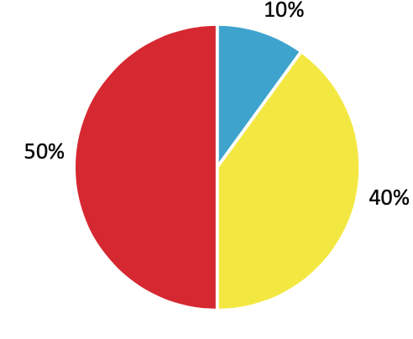
18-34 | 35-59 | 60+

By gender:

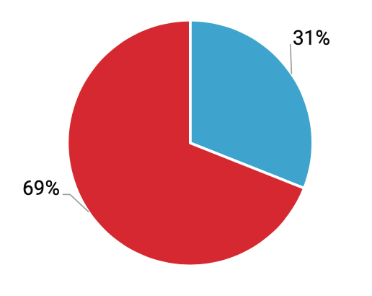

Male | Female

By categories:

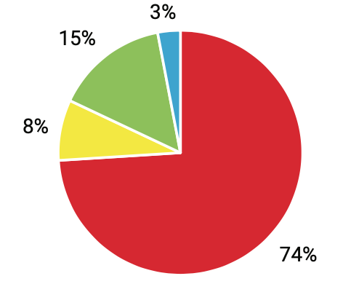

IDPs | Disability | Many children families | ATO participants

Public Relations

Ukrainian Red Cross Society continues implementing of the reputation management system that helps to track and shape public opinion about the Society's activities. It also actively strengthens cooperation with Ukrainian and international partners, public sector, and the media.

Ukrainian Red Cross Society any time welcomes constructive proposals from beneficiaries, regional/ district/ local organizations of the Society, public sector, and Ukrainian business structures willing to contribute to the humanitarian mission of the Red Cross Movement.

Joint projects and activities implemented in 2020 were covered using official communication channels of the Society. During the media projects implementation more than 650 information messages were distributed, and about 300 comments to media representatives were provided, including print media, web-based media, television (80 videos), and radio.

Top news in 2020 was the information about assistance to victims of floods in western Ukraine, fires in Luhansk region, and participation of the Ukrainian Red Cross Society in the international military exercise “Rapid Trident - 2020". The media got interested in the media project on blood donation – to the World Blood Donor Day the campaign "Victory is in Our Blood" was held jointly with the Ministry of Youth and Sports of Ukraine and supported by Ogilvy Ukraine Advertising Agency. As a result, in the first 3 weeks 7,850 blood donors joined the campaign in all regions of Ukraine. This is 2.5 times more than in 2019.

Special attention of the general public and media was attracted to some COVID-19 activities:

- 21.02.2020, Ukrainian Red Cross Society launched a Telegram channel for humanitarian activities coordination in Novi Sanzhary (Poltava region), where evacuees from China were under observation. The channel helped to ensure effective coordination of joint efforts of volunteers and volunteer organizations.
- CORONAvirus website was launched, which was created with support of the Danish Red Cross and funded by the Ministry of Foreign Affairs of Denmark.
- Creation of Ukrainian-language audiobook by British author and illustrator Helen Patuk, "My Hero is You", in which famous celebrities and talented children spoke in the heroes' voices. These voice actors were the cult musician Oleh Skrypka, announcer and TV presenter Timur Miroshnychenko, singer Svitlana Tarabarova, young participants of popular talent shows, and students of the Variety Art School and Production Center "Talant Production".
- Creation of 18 videos in the framework of the COVID-19 response, which were given the status of social advertising. They were broadcast by national TV channels. Besides, only during the first information campaign ("Stay Aware") on COVID-19 prevention and response that was conducted jointly with the Ministry of Health, the audience reached was more than 26 million people.
- Launch together with Vodafone Ukraine of the short number 88033 for charitable contributions, which would be used for overcoming of the COVID-19 pandemic consequences.

Moreover, more than 1,000,000 brochures and posters were printed and distributed during the information campaign on coronavirus infection prevention.

This year, the Ukrainian Red Cross Society took part in the 12th National Festival of Social Advertising® and received 3 awards in the nomination "STOP! COVID".

More than 450 COVID-19 posts were published on the official Facebook page and viewed by 10.6 million people, including 56 videos that reached the audience of almost 5 million people.

Popular Project through Quarantine

Campaign #WeAreClose (#Мипоряд): 27 videos were created together with representatives of the Jokers.film Production Group and Ukrainian cinema stars for attracting friends to blood donation under the Ukrainian Red Cross’ campaign "A Small Drop of Donor’s Blood Equals a Great Chance for Life" to support those who need blood for emergency intervention and therapy, because blood banks confronted a deficit of blood due to quarantine restrictions. Also, the JOKERS Production Group together with Ukrainian celebrities organized the charity action "We Are Close" with support of the Ukrainian Red Cross Society, where they called upon the community to support vulnerable people.

The World About Us:

- This year, the Ukrainian Red Cross Society’s employee became a protagonist of the full-length documentary "This Rain Will Never Stop".

The film tells the story of a young man with Ukrainian and Kurdish origins. Andrii Suleiman was born in the Arab Republic of Syria. In 2012, fleeing the war, he and his family left for Ukraine and settled in Lysychansk, Luhansk region, where the armed conflict broke out in 2014. At the age of 16 Andrii became a volunteer of the Ukrainian Red Cross Society and later a field officer of the Ukrainian Red Cross Society. Today 23-year-old Andrii works on the project "Reducing Disaster Risk Vulnerability in East Ukraine".

The monochrome film was shot in the Ukrainian Donbas, Iraqi Kurdistan, Syria, and Germany. The film has already become the best feature-length documentary at the Festival dei Popoli, the International Documentary Film Festival. The premiere in Ukraine will take place in 2021.

- participation in 5 international flash mobs;
- news about events and humanitarian missions implemented by the Ukrainian Red Cross Society were translated into Arabic and published on the information portal "Ukraine in Arabic".

General Activities of the Department in 2020:

- information support of various joint projects with partners. For example, the Ukrainian Red Cross Society and ROZETKA:

1. Action "Bag of Good" was launched to support people, who belong to vulnerable population, with hygiene products and household chemicals.
2. Charity event "Bag of Hope" was aimed at supporting children from families in difficult life circumstances and preparing for a new school year. The action was included in the TOP-25 effective marketing campaigns 2020 (according to the VD rating) (Dilova Stolytsia newspaper).

- 5 training on communication development and social networks maintenance for regional organizations of the Ukrainian Red Cross Society were held: 3 regional and 2 all-Ukrainian ones (online and offline), and written recommendations on communication with mass media and information activities were provided.
- Telegram chatbot developed
- new format of the Society’s news digest developed
- address book of the Society updated
- participation in 5 All-Ukrainian flash mobs
- adaptation of materials from the Red Cross Movement international members, including materials on reduction of the coronavirus spread
- covered the following topics on social networks: first aid, emergency response, Emergency Response Teams, tracing service, beneficiaries' histories, psychosocial support to the population, international humanitarian law, mine risk, blood donation, coronavirus awareness information, improvement of the organization’s image, partnership, visiting nurse service, and volunteering
- support of the Society’s regional organizations in information activities: Lviv, Kyiv, Luhansk, Kharkiv, and Donetsk regions
- participation in preparation of the corporate presentation package for corporate partners

Website of the Ukrainian Red Cross Society

The number of website visitors https://redcross.org.ua increased 3.5 times in 2020 compared to the previous year. Currently, there are more than 260 thousand active users on the website (in 2019the number was about 70 thousand).

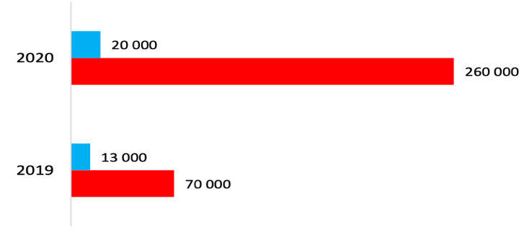

Number of visits per month | Number of website users

Every month almost 20 thousand people visit the website that is 33.5% more than in 2019, when the number reached over 13 thousand users.

Increase in the number of visitors on the website was achieves by providing relevant and necessary information that appeared in the "News" and "Coronavirus" sections, where everyone could learn about the Society's projects and download information posters about the measures for counteracting the pandemic (audience of 117 thousand readers reached). During the year the most popular sections were: "Contacts", "First Aid", "General Information," and "Vacant positions".

Readers from Ukraine (Kyiv, Dnipro, and Kharkiv), the USA, and Poland visited the Society's website the most often.

FACEBOOK

Active communication with users on social networks is maintained to provide additional information about the URCS activities.

In 2020, the number of subscribers increased by 25% and now equals 18,674.

One post reached 7-9 thousand people, but in a month some posts reached about 100 thousand people.

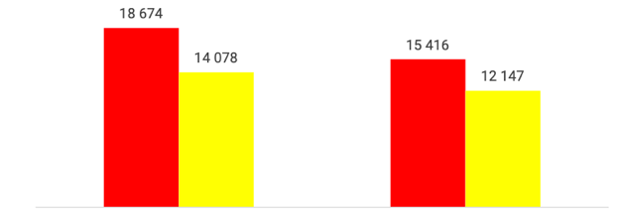
Facebook followers number Number of visitors, who LIKEd the facebook page

2020 | 2019

TWITTER

The social network covers information about the Ukrainian Red Cross Society’ activities in English: currently the number of subscribers is 1,992 (compared to 2019 the number increased by 10%, before it amounted to 1,819). The best tweets reach in 2020 was 500 impressions. The total number of impressions was almost 16 thousand.

INSTAGRAM

The communication channel, the audience of which are young people and teenagers. At the moment the number of the covered accounts-subscribers is 5,396 (in 2019 it was 3,064) that is more by 43%. There were published three times more news items (168 posts) than the previous year. Some posts reached up to 80 thousand accounts.

YouTube

Popularity of the Ukrainian Red Cross Society’s YouTube channel is growing rapidly. At the moment the videos on the channel have been viewed by almost 240,000 users, and there are 450 subscribers, which is more by 66% than the previous year.

Subscribers

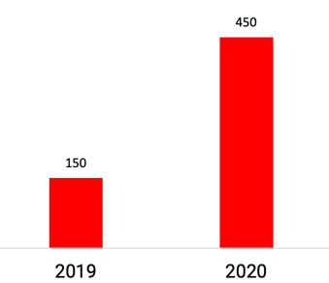

Number of views
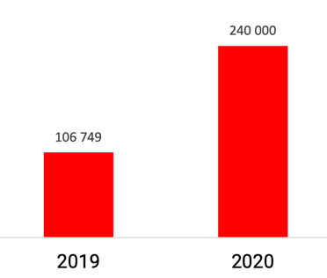

Risk Communication and Community Engagement

In April - November 27 million beneficiaries were reached through communication campaigns within the project “Support to the URCS’ COVID-19 Preparedness and Response" supported by the Danish Red Cross and funded by the Ministry of Foreign Affairs of Denmark.

- The all-Ukrainian campaign "Stay Aware" on quarantine safety rules with celebrities engagement has covered 26 million people in Ukraine. The 9-video campaign was created together with the Ministry of Health of Ukraine, the Institute of Cognitive Modelling, and the biggest media holding in Ukraine – StarLightMedia.
- Four animated videos about the nature of coronavirus and its prevention were created and received the social advertising status.
- On November 27, the Society launched the CORONAvirus website about the novel coronavirus providing the most important information in a convenient form.
- The audiobook "My Hero Is You" for children and adults about the coronavirus was created with Ukrainian celebrities’ participation.
- Posters and digital campaigns on information hygiene and the information accuracy check guide were developed.
- Digital posters on appropriate and environmentally sustainable use of personal protective equipment in cooperation with the Ukrainian environmental organizations.
- Collaboration with the creative agency Ogilvy on development of the national COVID-19 prevention campaign. The posters were placed in large food supermarket chains and in city light boxes in public places.
- Collaboration with the creative agency Ogilvy on internal communication strengthening for motivating the Society’s employees and volunteers to use masks and keep safe distance.
- Collaboration with the creative agency Ogilvy on development of the all-Ukrainian action for reusable fabric masks promotion with engagement of celebrities and designers for masks designing.
- Personal letter for families with current information about the coronavirus was distributed together with psychosocial and hygiene kits.
- Campaign with StarLightMedia for support of people exposed to the coronavirus. This was a series of TV videos with celebrities, who have endured the coronavirus.
- Coordination: the Society continues cooperation and coordination through various RCCE activities with UNICEF, WHO, and the Ministry of Culture and Information Policy of Ukraine.
- Feedback mechanism setting up on the COVID-19 situation in 12 regions of Ukraine.
- COVID-19 rumour tracking system is a part of the community feedback mechanism.

- 59 employees and volunteers of the Society participated in the risk communication and community engagement training.
- Communication for/ and with marginalized groups (Roma, homeless people) through printed materials and setting up a feedback mechanism for them.

From May to November 2020, the project "Preventing the Spread of and Responding to COVID-19 in the Eastern Conflict Areas, Ukraine" was implemented. Under the project 10 volunteers of the Ukrainian Red Cross Society were trained within the risk communication and community engagement direction and later worked with active community representatives.

From August to September, 10 risk communication and community engagement trainings were conducted for active representatives of 10 key communities of Donetsk and Luhansk regions. The trainings were attended by 55 participants, who still have been informing people, by phone and directly, about the COVID-19 risk reduction, symptoms, prevention, disease control, hotlines and information centres that provide help and answers to questions, etc. On the other hand, active community representatives receive feedback from beneficiaries about rumours, observations, fears, stigmatization, pressing issues, needs, etc., to continue working effectively and supporting these communities.

During the project with the coordination support of the Society’s employees and volunteers 3,050 households in Donetsk and Luhansk regions were informed and provided feedback.

In addition, within the project 10 community engagement workshops were held and attended by 65 local opinion leaders, namely, chairmen and employees of local councils, directors and deputy directors of local educational institutions, culture centres, employees of local health facilities, social workers, informal community leaders, etc.

Charades game
which a person has to explain to the rest of players,

During the workshops participants provided feedback, identified the most vulnerable populations in their communities and their needs in the context of COVID-19, and sought ways to support those populations. In the end, the participants developed action plans for minimizing the COVID-19 risks. During the following months, they independently implemented these activities in the communities with the coordination support of the Risk Communication and Community Engagement Manager. Thus, from September to November, 25 such activities were carried out and involved about 800 beneficiaries-residents of 10 communities.

The activities were somewhat complicated by increase in the disease incidence, which led to partial lockdowns at the most of target locations. Challenges with technical support and communication in remote areas made online activities difficult or impossible.

There was published a total of 39,000 posters and leaflets on topics "Coronavirus: prevention, treatment and spread", "How should persons 60+ act during the quarantine", "COVID-19: how to protect yourself", "How to protect yourself from the coronavirus", "Hand hygiene. Why, how and when?" and the leaflet about the Let's Talk support line, which was distributed among the health care workers. Other printed materials were distributed a training and workshops, and also directly to a wide audience as a part of hygiene kits distribution.

Besides, four videos were created on topics "Contactless Games" (for children), "Safe Behaviour" (formation of a safe behaviour trend among teenagers), "Information Hygiene", "Emotional Health". The video was communicated to a wide audience through various communication channels: social networks (Facebook, YouTube, Instagram), the official website of Ukrainian Red Cross Society, and upon granting the status of social advertising through TV channels and in public places. The four videos received about 500,000 views in total.

PROCUREMENT ACTIVITY

- 65 meetings held

- 282 questions considered

- 170 contracts with suppliers concluded

- 422 procurements through direct contracting carried out (by comparing procurement item prices from different suppliers, the procurement item value did not exceed 50,000 UAH)

- 3,172 shipments of goods and materials (inventory items) made through the Nova Poshta delivery service

